Table of Contents

1. Java script fundamentals 3

1.Data Types 4

2. let, const and var 5

3. Basic Operators 6

4. Strings and Template Literals 6

5. Type Conversion and Coercion 6

5. Truthy and Falsy Values 6

6. Equality Operators: == vs. === 7

7. Switch case 8

8. History of JAVASCRIPT 8

9. Strict Mode 8

10. Function declaration vs expressions. 9

11. Array 10

12 Objects dot vs bracket notation 10

2. Development Guide 11

1 Software lists and setup 11

3. Java script in browsers 12

1. DOM 12

2. Guess My Number! Game 12

3. Open Overlay Modal (Manipulate CSS class from js) 13

4. Capturing Keyboard events 13

4. Pig Game 14

4. How Java script works internally 14

1. JavaScript re-defined 14

2. JavaScript Engine 15

3. Just-In Time Compilation of java script engine. 16

4. JavaScript Runtime 17

5. Execution context and call stack. 18

6. Scope and The Scope Chain 20

7. Scope Chain vs Call Stack 22

8. Hoisting (variable environment of execution context) 23

9. Temporal Dead Zone 23

10. THIS Keyword 25

11. Object assign method 27

5. Data Structures, modern operator and Strings 27

1. Destructuring arrays 27

2. Destructuring objects 28

3. spread operator (…) 30

4. Rest operator (…) 31

5. Short circuiting operator (&& and ||) 31

6. Nullish coalescing operator (??) 32

7. Looping arrays: The for of loop 33

8. Enhanced Object Literals 33

9. Optional Chaining (?.) 34

10. Looping over Objects (keys, values and entries) 35

11. Set 36

12. Map 37

13. Array vs set vs map vs object 38

14. String 38

6. Functions 40

1. Default parameters 40

2. First-Class Function vs Higher-Order Function 40

3. call, apply and bind method 42

4. Immediately Invoked Function Expressions (IIFE) 43

5. Closures 43

7. Working with Arrays 45

1. some useful array methods 45

2. looping array 48

3. looping map and set 49

4. Data Transformations in array with Map, Filter, Reduce and find 49

5. Different ways to create and fill array 50

8. Number 51

1. converting and checking Numbers 51

2. Math class methods 53

3. BigInt 54

4. Date and Time 55

5. Internationalization Dates and Numbers(Intl) 55

6. Timers 56

9. Advanced DOM and Events 57

1. HOW THE DOM REALLY WORKS 57

2. Selecting, Creating and Deleting Elements 58

3. Styles, Attributes and Classes 59

4. Types of event and event handlers 60

5. Event propagation: capture and bubbling. 60

6. DOM Traversing 62

7. Intersection Observer API 63

8. Some useful DOM Events and there Life Cycle 63

9. Efficient Script Loading: defer and async 64

10. Object Oriented Programming 66

1. OOP in general 66

2. OOP in JavaScript 69

3. Constructor functions and new operator 70

4. Prototypes 72

5. Prototypal inheritance and chaining works-> 74

6. ES6 classes 76

7. Getters and Setters 77

8. static method 77

8. Object.create 78

9. Inheritance between classes: constructor functions 79

10. Inheritance between classes: ES6 classes 81

11. Inheritance between classes: traditional way via Object.create. 83

12. Encapsulation: protecting properties and methods 84

13. summary ES6 classes 85

11. Asynchronous JavaScript 86

1. Synchronous and Asynchronous Code 86

2. AJAX implementation via XMLHttpRequest 87

3. how request response works 88

4. Maintain sequence in ajax calls (CallBack hell) 89

5. AJAX implementation via Promises & fetch API 89

6. Handle errors in Promises 91

# Java script fundamentals

1. Java script is a high level, object oriented, multi-paradigm programming language.



1. JavaScript rule and convention for variable names is same as java.

## 1.Data Types





1. In java script all the numeric are floating points. i.e. if(10===10.0) is true.
2. typeof will give the type of value particular variable hold.

Let val;



3. primitives are stored in stack and objects are stored in heap in java script. For object there reference are stored in stack but the entire object is stored in heap.



## 2. let, const and var

1. let and const are introduced in es6.



2. In javascript we can also create variable like this ->

newVar = 10;

console.log(newVar);

// it will create newVar variable and attach it to global object. Where as var is attached to functions scope only.

3. If object is created via var it will become field of current this object. But let and const does not create field inside this object. For example->

var x = 2;

here x will become window object field. As here this is window object. (later section for detail explaination)

## 3. Basic Operators

1. 2*3= 6, 2**3=8 (it is just like pow), 10-8=2

2. plus operator can also be used to concat string.

## 4. Strings and Template Literals



1. Template literals are introduced in es6 and provide below extra features –

1.1 can use multiline strings without need of writing \n\ for newline.

1.2 can use placeholders inside string ${} for actual value and can calculate expression also.

1.3 can use ‘ and “ also inside string without escape character.

## 5. Type Conversion and Coercion



1. type conversion is a way by which we can convert from one data type to other.

2. type coercion is way by which java script convert implicitly to some data type according to below rules ->

2.1 ‘+’ operator will perform mathematically add operation till numbers going from left to right. once string is found, number will be converted to string implicitly and concatenated.

2.2 for ‘-‘ operator it will subtract normally. But for string like ‘22’-‘1’ it will convert string to number implicitly and give result in number i.e. 21.

2.3 same like minus operator, /,* also works.

## 5. Truthy and Falsy Values

1. By default 0,’’,null,NaN,undefined and false are considered false values when used inside if block or logical operators.

2. if(undefined) or if(0) or if(null) will make code inside this if block not to be executed.



## 6. Equality Operators: == vs. ===

1. === check is strict checking which check data type and value both. Where as == is without strict check. == perform type coercion when needed to perform comparison.

2. !== and != are just not equal representation of not equals.

Example 🡪

let val='18';

if(val==18) {

console.log('== check');

}

if(val===18) {

console.log('===check');

}

**Output ->**

== check

## 7. Switch case



## 8. History of JAVASCRIPT



## 9. Strict Mode

1. strict mode can be enabled by adding it at first line of java script file. Once enabled it will protect developer from some mistakes which javascript not complaint earlier.

Example 1->

const firstName = ‘kush’;

let value = 10;

if(firstName===’kush’) {

values=29;

}

Console.log(value); //output 10.

Above code works because js will create new variable values with 29. But with script mode enabled js will give error that values is not defined.

2. strict mode is enabled using below line

‘use strict’;

Example 2->

Strict mode restrict programmers to use reserved words to be used in code as a variable. Like interface, private, if etc. even though some of these reserved words are still not there in js and will be introduced in future.

let private =’ss’; //give CT error if strict mode is on

## 10. Function declaration vs expressions.

1. function expressions also called anonymous function and they are assigned to a variable like any other values.

2. anonymous function can be invoked only after it is assigned to a variable otherwise js will give CT error. But normal function can be called in line 1 and in later line will have definition.

3. from es6 we can write lambda expression to represent function. It is just a simplified way of writing anonymous function. The difference b/w anonymous function and lamba is that lamba does not have this reference.





## 11. Array

1.there are two ways to create array. One using new operator and other using [] bracket. Always prefer [] bracket way as it will lead less confusion. As new Array(10,20) will create array with 2 elements. But new Array(10) will create array of size 10 with all 10 undefined values.





## 12 Objects dot vs bracket notation

1. in java script objects contains key value pairs where key is always string and value can be anything.

2.every property value can be accessed either by dot or by bracket notation. Only difference is dot operator take static field. If we use field which does not exists both way give undefined value.

In below example input from prompt passed is location.



Example 2 with function as a value of a property.



Example 3 –



# Development Guide

## 1 Software lists and setup

* Download and install vs code and node js.
* Go to terminal and check node -v for version.
* Type – npm install live-server -g
* Now in vs code create any html file and script file.
* Now goto path of above file via terminal and Type –> live-server
* It will launch application in browser with url -> <http://127.0.0.1:58442/>
* Further Changes will be hot deployed.

2 Debug

* console.log -> log with normal text
* console.warn -> log with warn text
* console.error -> log with error text
* console.table -> if logged with object. It will display in console in tabular form key,value fields.

# Java script in browsers

## 1. DOM



1. DOM allows us to make javascript interact with browser.
2. DOM Tree is generated from an HTML document. Tree structure root node is document. And by using document we can extract all other child nodes. example by document.querySelector(“#id”);
3. Html is the first child of document. As usually html page starts with html tag. And rest of the tree resembles the content inside the html page.
4. By using dom we can access html content inside js and can modify content according to need.



## 2. Guess My Number! Game

1. Computer will randomly select a Number from 1 to 21 and then ask the user to guess it in maximum 20 attempts.

2. once user enter the number which exceeds the random number, message will be displayed that It’s too high else too low.

3. On tight guess it will current score. And if it is higher then prev max it will be the max score.

4. user can play again by clicking again button.

Git utl –

<https://github.com/kushguptacse/JavaScript/tree/main/guessMyNumber>

## 3. Open Overlay Modal (Manipulate CSS class from js)

1. create an application on which on click of button modal overlay open and on close button of overlay it got closed. Also on click on esc button press overlay closed. And on click of outside of popup it get closed.

2. <https://github.com/kushguptacse/JavaScript/tree/main/model>





## 4. Capturing Keyboard events

* To close the overlay on click of Escape button. We need to attach eventLisetener with keyDown event to document object.

*const* closeModel = ()=> {

    modal.classList.add('hidden');

    overlay.classList.add('hidden');

};

document.addEventListener('keydown',(*event*)=>{

    if(event.key ==='Escape' && !modal.classList.contains('hidden')) {

        closeModel();

    }

});

## 4. Pig Game

1. two player game. For detail flow chart can be viewed in java script git repository.

Checkout flow diagram and code from git.

# How Java script works internally

## 1. JavaScript re-defined



1. High Level -> It manages memory management by it owns. Programmer don’t need to allocate or deallocate memory.

2. Garbage-Collected -> automatically collects garbage to clean memory.

3. Interpreted or Just-In Time compilation -> it happens inside javascript engine.

4. Multi-Paradigm -> support different style of programming. Like it supports all -> procedural , functional, object oriented.

5. Prototype-based Object Oriented -> every thing in JS is objects except primitive values. To achieve inheritance prototype is used.

6. First-class function -> it means function are treated like normal variables. i.e. can be passed as argument or returned from function.

7. Dynamic language-> variables data types association are dynamic and can also be changed.

8. single Thread and Non-blocking event loop ->



## 2. JavaScript Engine

1. JS Engine is a program that executes java script code. All browser contains this engine. One of the popular js Engine is V8 engine created by google. It is used in chrome and also nodejs. That is same engine can be used to built js app inside or outside the browser.

2. JS Engine contains two components Call Stack and Heap.



3. as we know machine understands only 0/1. So we need to convert javascript code into machine code so that it can be executed by processor. There are three approaches for that – compilation, interpretation, and Just-in time compilation.



4. earlier java script is Interpreted. i.e. source code converted into machine code and then executed directly line by line. Which is slow as the whole process is repeated line by line.

5. now modern java script language uses JIT compilation. i.e. first entire source code is converted into machine code. And then executed immediately. It is different with normal compilation in a way that no portable binary file is generated in jit compilation.

## 3. Just-In Time Compilation of java script engine.

1. first the entire js code is parsed and converted into a data structure called abstract syntax tree (AST).

2. in this parsing phase any syntax error is also checked. And this AST is later used to generate machine code.

3. this AST tree has no relation to DOM.

4. then this AST is compiled into machine code. After that code is executed. Execution happens inside call stack.

5. just to make code running fast code the JIT process generates machine code unoptimized without applying too much logic. And once the code is already in running state in call stack, a separate thread will revisit the syntax tree to see for further optimization and then the optimized version of machine code is replaced with un-optimized code.

6. this special thread we cannot access from with-in our code. And it is not part of main thread.



## 4. JavaScript Runtime

1. Runtime is a container which has everything which is needed by javascript. In most of the cases it is browser. It can also be node.js.

2. Runtime has three components- JS Engine, Web API’s and CallBack Queue.

3. Web api are the functionality provided to the engine which can be used inside our javascript code like DOM, Timers, console interaction via window object.

4. all the callbacks are added into callback queue and on execution it is added into call stack by event loop. For example function of click event of button is callback function which is added to callback queue on registration of click event. This function is moved into callstack once button is clicked.

5. with the help of event loop this click event function call is non blocking.



============================JavaScript Runtime in Node.js ================================



In Node.js environment WEB api does not exists as it is provide by browsers. Here instead C++ bindings and Thread Pool is used.

## 5. Execution context and call stack.

1. once the code is compiled into machine code. Execution phase starts.

2. In it first global execution context object is created. Which is responsible for executing code which is outside the function.

3.Execution Context – is an environment in which a peace of javascript code can be executed.it stores all the necessary information for that peace of code to be executed.

4.for each function a new execution context is created to execute code inside that function. They all together make the call stack.

5.Only one global execution context is created. And it will execute top level code.

6. only when the function is called then only it’s specific execution context is created and that code is executed.

7. In Execution CPU basically execute the machine code.



8. Inside execution context below data is present –



* Variable environment contains all the variable declarations, functions code and argument object contains the list of objects need to be passed into function call.
* Scope chain-> by it reference is made between variables of different scopes to be accessed.
* This keyword.

9. In arrow function this and arguments object is not available.

10. All the above information data is prepared and available just before starting execution.

Example 🡪 shows the initial phase of execution context.



11. Flow explanation ->



1. When code starts first global execution context is created and pushed into call stack.

2. Inside it call to first method is invoked. Now first execution context is created and pushed into stack. Now code inside first method executing.

3. Now call to second method is made. Its execution is created and pushed into stack. when second method finishes it is pooped from call stack. And first method remaining lines of code start executing.

4. now when first method finishes. It is popped from call stack.

5. when last line executed. Even after that global EC remains in stack. When the browser is closed then only global EC removed from call stack.

## 6. Scope and The Scope Chain

1. Scope is an environment in which a certain variable is declared. Global scope, function scope and block scope are three types of scope.

2. scope of a variable: Region of our code where a certain variable can be accessed.

3. let, const are blocked scope. var is function scoped. it means if variable declared as var inside if block inside a function. Then it will be available to whole function for use. But if it is declared as const or let then it will be available inside if block only.

4. functions declared with strict mode on are also blocked scope. otherwise they are function scope. i.e. can be invoked inside enclosing function even if declared inside a block.

5.Scope chaining -> if a particular variable is not available in current scope it is searched in parent scope till it reaches global scope. if not found error is raised.

6. if a variable is re-declared . then preference will go to inner-scope in inside code. As first inner scope is searched in scope chain.



7. scope chaining does not work in downwards direction. Suppose a variable in global scope want to access a variable present inside a function. Then it cannot be referenced.



7. For example ->



* Here myName variable is available in globalScope.
* first method scope (function scope) has age variable and millenial variable available. myName is available to first function via global scope chaining.
* If block scope has decade variable which is local to that block only and since millennial is declared as var it is attached to first method scope and hence even available to second function also. But decade variable is local to if block only.
* Method second is also another function scope and has job available. Apart from that myName comes from global scope and age, millennial comes from first function scope.
* If block and second method scope cannot share each other variables.

## 7. Scope Chain vs Call Stack

1. call stack contains execution environment according to the methods called order. With global execution context as the bottom entry. Each execution context has variable execution and scope inside it (As we know that execution context contains variable environment, scope chain and this keyword inside it)

2. variable environment contains all the arguments and variable declared inside that function.

3. In below example reference error will occur as variable c and d are not present in global scope.





## 8. Hoisting (variable environment of execution context)

1. It makes some types of variables accessible/usable in the code before they are declared. (making declaration move to the top of the code). In creation phase it happens.



2. Variables declared via let/const are not hoisted. So if we try to access variable before declaring it reference error will get (CT error).

3. for function expressions and arrows – they will follow var rule if declared var. if let then let, if const then const.

## 9. Temporal Dead Zone



1. to make that work for let and const. special zone – temporal dead zone is created. i.e. it is the area from starting of code to the line const/let is declared. By this if in code variable is accessed in TDZ reference error is generated. And once declaration line reached it is available for use. By TDZ also constant works like that. As in case of var first variable moved to undefined value till declaration is reached. It kind-of violates the constant rule.

**2.** **WHY HOISTING created initially if it leads to so much confusion?** -> to support function calling before the function is declared.

Example –



3. Function Example -



4. Variable hoisting can lead to issue which are hard to find. For example in below case since num value is undefined and hence Boolean condition get true and record deleted. But we expected it to be 10.



5. var variables become part of window object. Let and const are not.



## 10. THIS Keyword

1. this is a part of EC and points to the owner of the function. In general method can be called by 5 ways ->

1.1 object calling the method. As shown in example screenshot

1.2 simple function call -> here it point to undefined in strict mode. Else to window object.

1.3 arrow function -> arrow function does not have own this keyword. It will point to the enclosing function this keyword.

1.4 event listener -> DOM element on which handler is attached.

1.5 new, apply, call, bind -> will discuss it later.



Examples ->



Example 2 Regular Function vs ARROW Function ->



Example 3 -> this inside a function of a object.



Example 4-> arguments are not available inside lambda function.



## 11. Object assign method

1. Object class assign method is used to copy object. It will copy first level objects only. It will not create deep copy.



Example 2-> shallow copy example



# Data Structures, modern operator and Strings

## 1. Destructuring arrays

Example of destructuring array.



Example 2 ->



Example 3-> nested array destructing and default values



## 2. Destructuring objects

1. instead of using [] to hold object fields {} will be used. Since here order does not exists, matching field name is used to identify the field. “:” is used to give alias and “=” to assign default value to property if field in referenced object does not exists.

Example 1 - >



Example 2-> nested destructuring



Example 3 -> assign value to existing variables with same name as of object property.



Example 4-> use-case of passing object via function and de-structure directly.



## 3. spread operator (…)

1. It is different from destructing in a way that we don’t need to create separate variables for each value. It is just like exploding the entire array into array of individual items.

Example 1 -> prompt will provide popup to enter toppings



Example 2-> spread operator with objects.



## 4. Rest operator (…)

1. ‘…’ operator work as both spread and rest operator. If used right hand-side of ‘=’ operator it will behave as spread operator. On left it will work as rest operator. Spread and rest operators are opposite of each others.

2. rest operator must be used at last as it combines all the elements from current position till the end.

3. just like spread operator it can be used with both array and object.

4. example ->



5. function example with rest and spread operator ->



## 5. Short circuiting operator (&& and ||)

1. javascript follow rules for conditional operator-> it can take any data type as input, can give any data type as output and short circuit.

2. OR operator will return the frst truthy value or the last falsy value whichever is applicable.



3. And operator will return the first falsy value or last truthy value whichever is applicable.



## 6. Nullish coalescing operator (??)

1. In traditional || operator 0 and ‘’ taken as falsy value which we don’t want always.

2. ?? will consider null and undefind as falsy value. But 0 and empty string as truthy value

## 7. Looping arrays: The for of loop



## 8. Enhanced Object Literals

1. In ES6 new enhancement made in object literals ->

1.1 in object key can also be result of an expression just like value.

1.2 to refer an object inside an object. Keyname can be omitted if reference variable name is key itself.

1.3 inside object function keyword can be avoided.

Example 1.1 ->



Example 1.2 ->



Example 1.3->



## 9. Optional Chaining (?.)

1. reading property of undefined gives type error. So to avoid if check we can use optional chaining also.

2. in a.b.c?.d => d field will be executed only if c is not nullish. In case of undefined or null value of c. output undefined is returned directly and d will not be evaluated.



Example 2- nullish + optional chaining example



Example 3-> method and array example of optional chaining



## 10. Looping over Objects (keys, values and entries)

1.if we wanted to get arrays of keys present in objects. Use Object.keys method.

2.for arrays of values. Use Object.values method

3.for arrays of <key,value> pair use Object.entries method.



Example 2- entries



## 11. Set

1.it is introduced in es6. Common methods are has, add, delete, clear. And property - size.



Example 2-



## 12. Map

1. it is similar to object but here key can be any data type not just string.

2. useful methods are – set, get, has, delete, clear and property - size

3. set method returned modified map and hence can be chained.

4. internally map is an 2D array where each 1D array is of size 2 with first index as key and second as value.

5. to iterate over map => entries(), keys() and values() method is there. By-default for(const entry of map) also behave same as entries method.



Example 2 ->



## 13. Array vs set vs map vs object



## 14. String

1. string are primitive in javascript . const d = ‘hello’

2. so how we can invoke function on primitive. Actually, when we call function on string it is boxed into String Object and then function is called. And if that function return string back then resultant object is unboxed into string primitive and returned.



Example 2-> string methods



Example 3 -> check if passenger seat is the middle seat.



Example 4 -> includes, startsWith, endsWith, toLowerCase, trim, toUpperCase



Example 5 -> Some more String methods



# Functions

## 1. Default parameters

1. with es6 we can give optional values to the argument of function in function definition itself by using ‘=’ operator.

2. java script supports pass by value only. In case of objects the memory reference itself is a value which is assigned to variable just like java.



## 2. First-Class Function vs Higher-Order Function

1. first class function means in java functions are just a value like any other objects. And hence can be used everywhere where a variable can be used.

2. by above feature functions can be used as higher order function which means function can return another function(which also called call-back function). Function can be passed as an argument to a function.



Example 2-> Function passed as argument to another function (call-back function)



Example 3-> Function returning another function



## 3. call, apply and bind method

1. In javascript inside object we can declare function as a field and inside that function can use ‘this’ to reference other fields inside function. But if function is called like normal function then this will be passed as undefined(in strict mode).

2. so by using call and apply method present in function object, we can pass custom this to be used.

3. difference b/w call and apply is that call take var-args where as apply take array as method arguments.

example 1 call and apply->



4. bind is different then call and apply. It allows this to be set via bind function and return function with binded this.

It means now by using returned function of bind method, if we call this is already set. It is helpful in a way that via bind we are not calling actual function ( as was with call and apply) but we are just setting this only and now can be later called multiple times via returned function.

Example 2 bind ->



Example 3 -> use of bind to pass this without calling method.



Example 4 use of bind to fix first argument->



## 4. Immediately Invoked Function Expressions (IIFE)

1. it means a function can be executed only once in a lifetime. For that we need to create anonymous function and call it immediately. For that wrap function inside ‘()’ and then call it directly. Example –



## 5. Closures

1. closure is just like concept by which function can access fields declared in parent function even after parent function execution context is no longer on call stack.

2. this is possible because function will always have access to variable environment of the execution context in which it was created. Even after the parent function execution context is no longer on call stack.

3. variable environment attached to the function at the same time and place on which the function is created.

4. it means even if the execution context is destroyed and no longer in call stack. The variable environment still living in the memory and child function has access to it.

Example 1-



* Here once the secureBooking done execution it is no longer in call stack. The booker variable just holds a function returned (just like writing function and assigning it to booker variable). But by closure booker will have access to variable passengerCount declared in parent secureBooking.
* As we know via scope chain first a variable is searched locally if not found parent is searched. Here for booker() scope, parent is global scope. and global scope does have passengerCount variable. before looking into the global scope to find passengerCount, closure is used to find the variable and if variable not available via closure then it is searched in parent scope. It means priority is given to closure then to scope chain.
* passengerCount is available via concept by which a booker function will have access to variable environment of the function inside which it is created. Which is secureBooking here. This access is given to the booker function at the time of function creation itself.

Example 2 -> Without returning function closure in action



Example 3-> closure timer example



Here when boardPassengers called first welcome line is printed then setTimeout function is called with our function as first argument and wait time in ms as second argument. So the function will be executed in 3 seconds. Before 3 sec next line is executed.

So when actually the function passed inside timer function is executed, variables n, wait and perGroup is available via closure. As it is called later which is outside the execution context of boardPassengers.

Example 4 -> closure example for click event callback function



Here on click of body of html page color is toggled between red/blue. By the time callback function passed in eventListener is executed IIFE is not available in call stack and hence header variable is not available via scope chain. But via closure (variable env of IIFE) header is available to the callback function.

# Working with Arrays

## 1. some useful array methods

Example 1-> push, pop, shift, unshift, indexOf, includes



Example 2-> slice, splice, reverse

1. To remove element from array itself use splice method. ( first arg is the index of element as a starting point to be removed from and second arg of splice method is number of elements needed to be removed from array starting from start index).

2. slice does not remove from original array.



Example 3 -> join, concat



Example 4-> includes, some and every

1. arr.includes(item) will check if item is present inside arr array. If yes return true.

2. arr.some(item=>item>20) will check if atleast one item exists in arr whose value is greater than 20.

3. arr.every(item=>item>20) return true if every element is having value greater than 20.

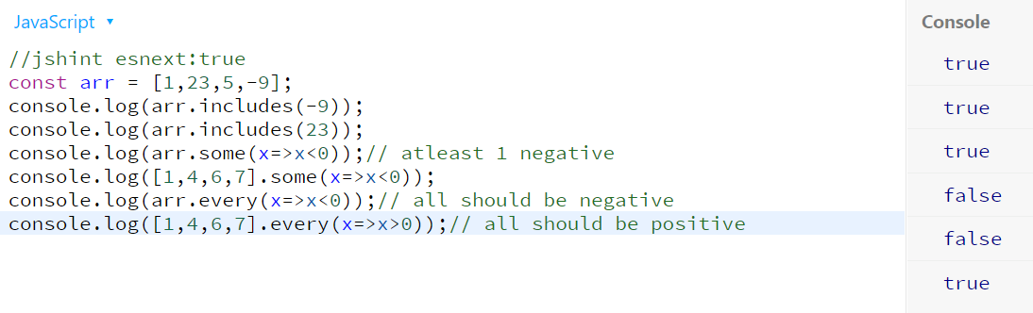

Example 5 -> flat, flatMap

1. flat method convert 2d array into 1d array. By default it flattens 1 level deep array only.

2. we can pass int argument which will tell flat method nested deep level. By default it is 1.

3. It is very common that map and flat are used together. For that single method flatMap can be used. It maps the value as well as convert it into single array at the same time. And hence perform better.

4. flatMap can do only 1 level deep flattening.

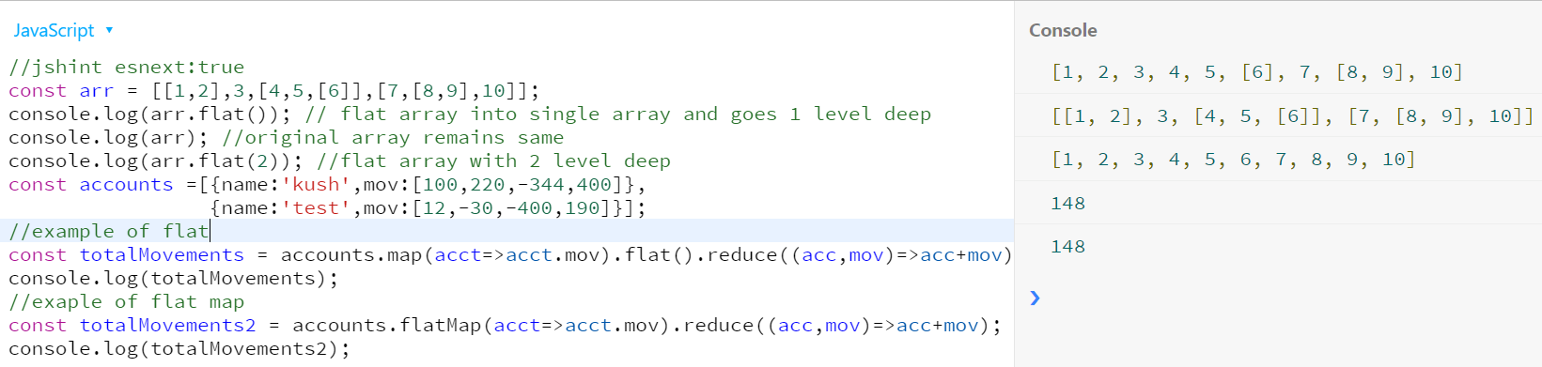

Comparison chart of array methods ->

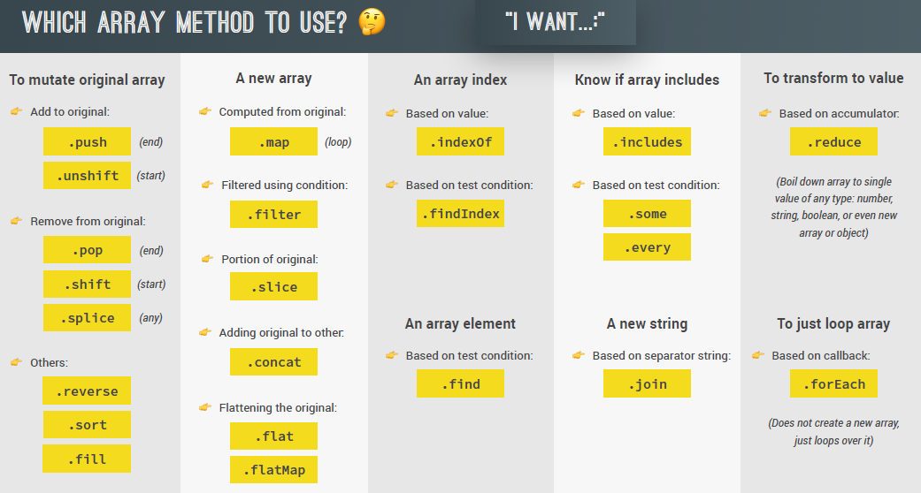

## 2. looping array

1. arr.forEach passes the current element, index and entire array as argument to the callback method.

2. forEach method cannot use continue and break. return also just return from current iteration. For next iteration in array callback function will be called again.

Example 1->



Example 2 ->



## 3. looping map and set



## 4. Data Transformations in array with Map, Filter, Reduce and find

1. map is used to convert every element of array to some new value according to callback function. It always create new array.

2. filter used to filter out some elements according to callback function logic. It creates new filtered array as result.

3. reduce take entire array and return single value(like adding all elements of array). It takes first arg as callback function and second arg as start value of accumulator (i.e. result)

4. find will return the first matched array object.



Example 1 –

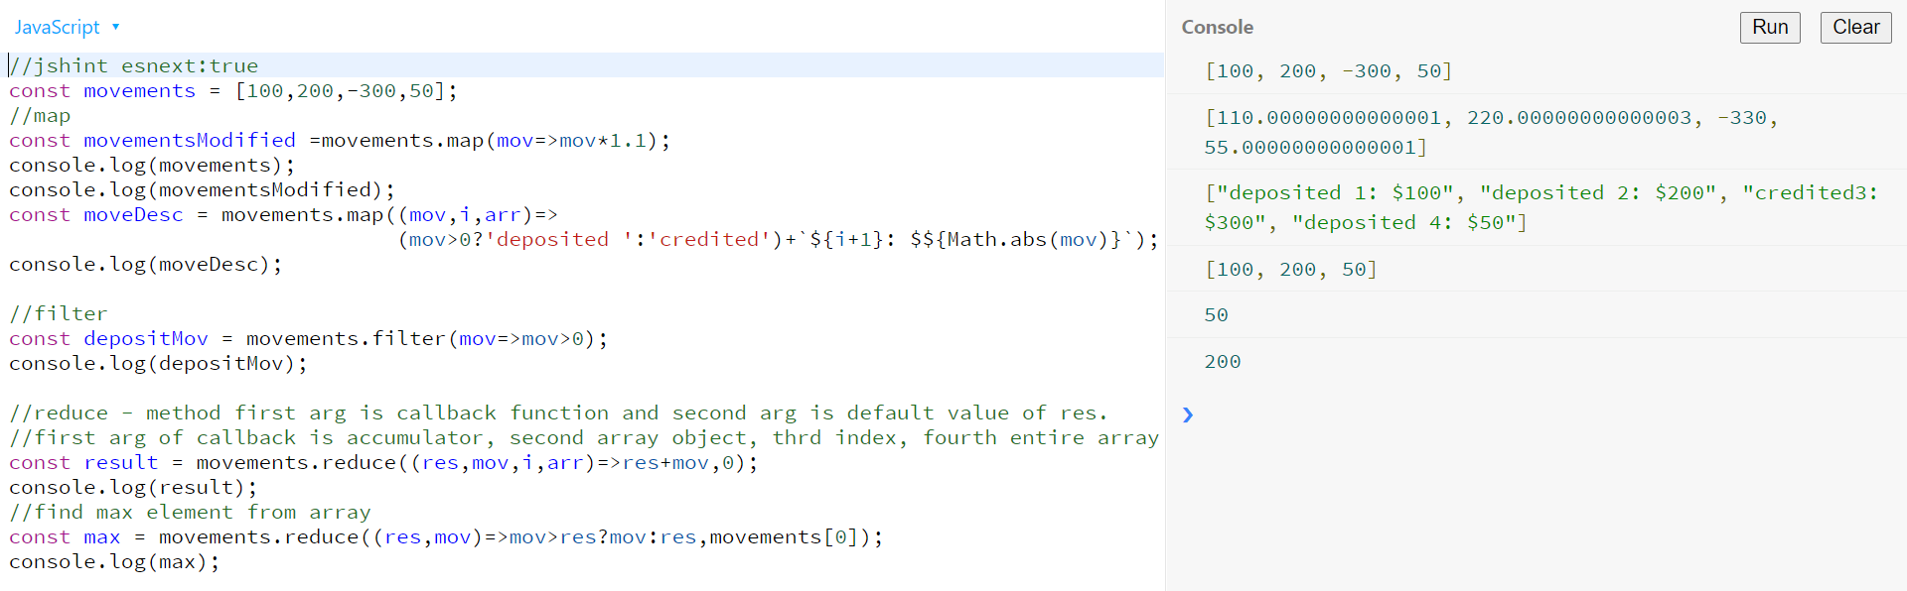

Example 2 with find method->

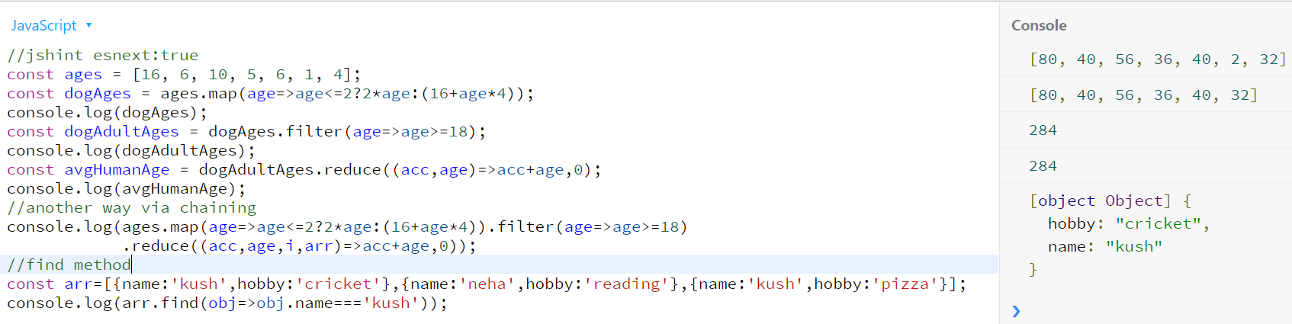

Example 3 reduce with object ->

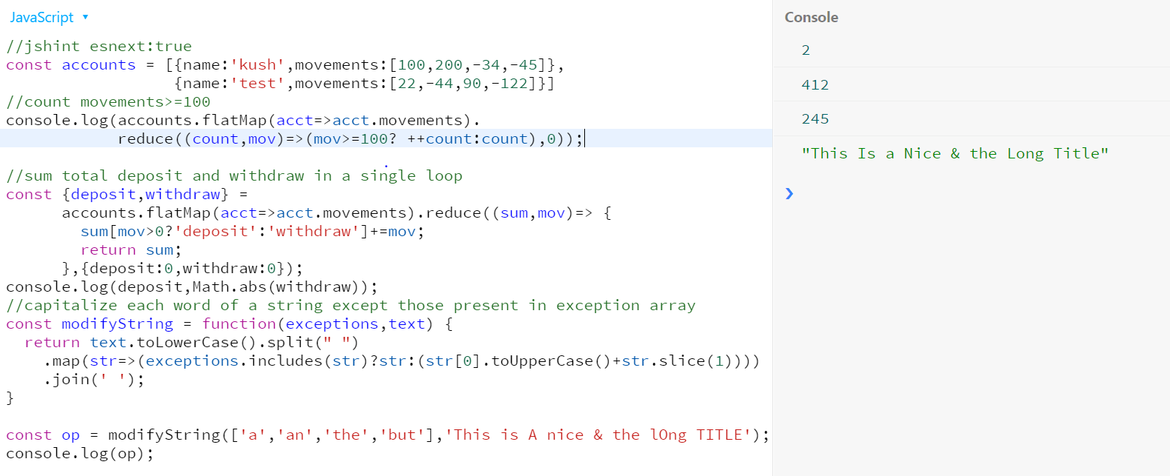

## 5. Different ways to create and fill array

1. fill method fills the array with value passed. ( overwrite if already exists) it has 3 arg. 1st arg take value to be filled , second arg start index and last arg is the end index-1.

2. from method can be used also to create array and fill value. It take first arg as object like {length:7} for length of array and second arg as callback function which is similar to map function.

3. from method can be used where we want some logic to initialize array with some values. And from method can also take any iterable as argument not just array.

Example -> fill and from method

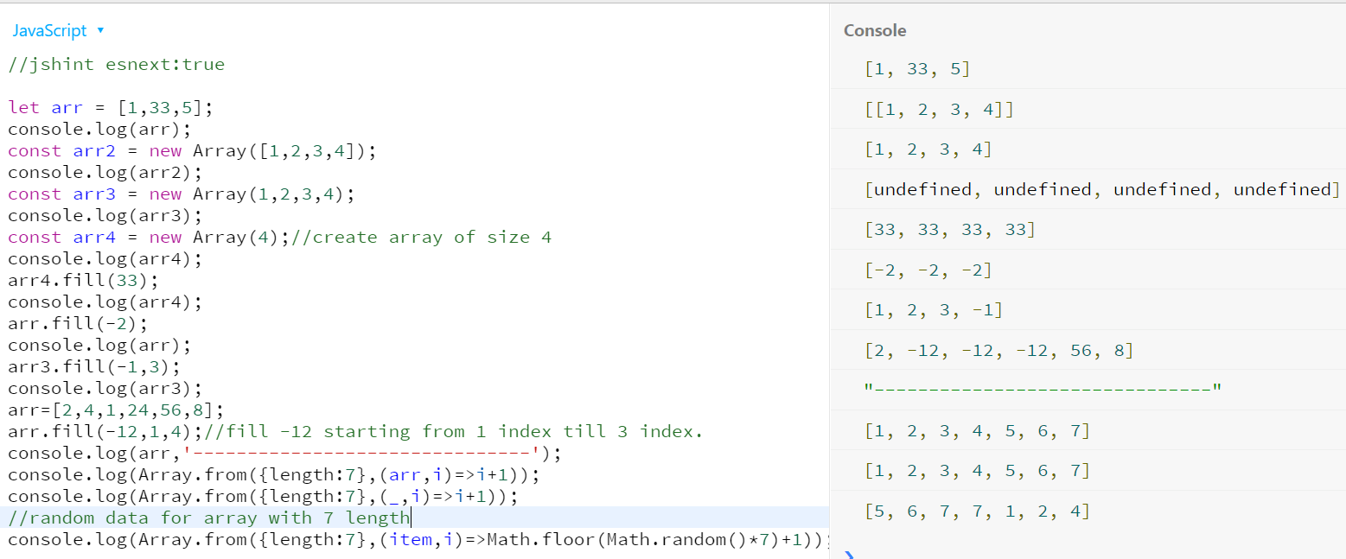

# Number

## 1. converting and checking Numbers

1. In java script all numbers are same. i.e. 2===2.0 gives true

2. In java script all numbers are store in base64 binary format. So certain numbers are difficult to store. Like fractions

Example 0.1+0.2 = 0.30000000000000004

3. By using + operator in-front of string. String will be converted to number. If entire string cannot be converted to number NaN will be returned.

4. parseInt and parseFloat method can be used to convert string to number. Only rule is that string should start with number else NaN will be returned.

5. Number.isFinite can be used to check if input is a Number

6. Number.isNaN can be used check if input is NaN.

7. Number.isInteger can be used to check if a number is integer (no decimal and no string)

Example 1->

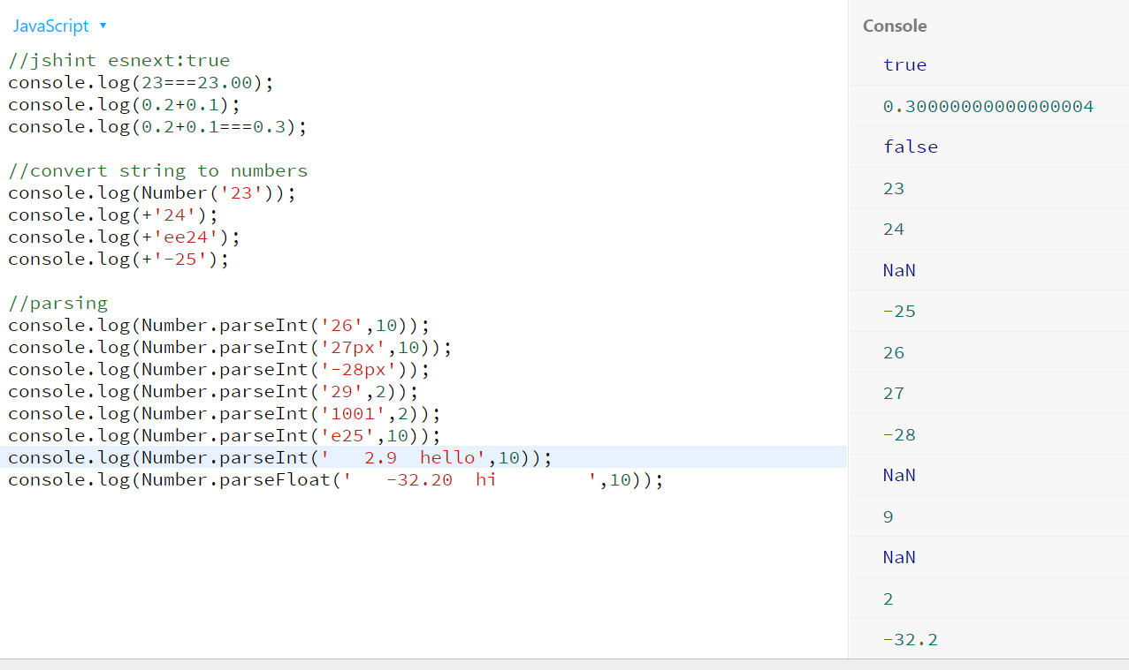

Example 2-> isNaN and isFinite

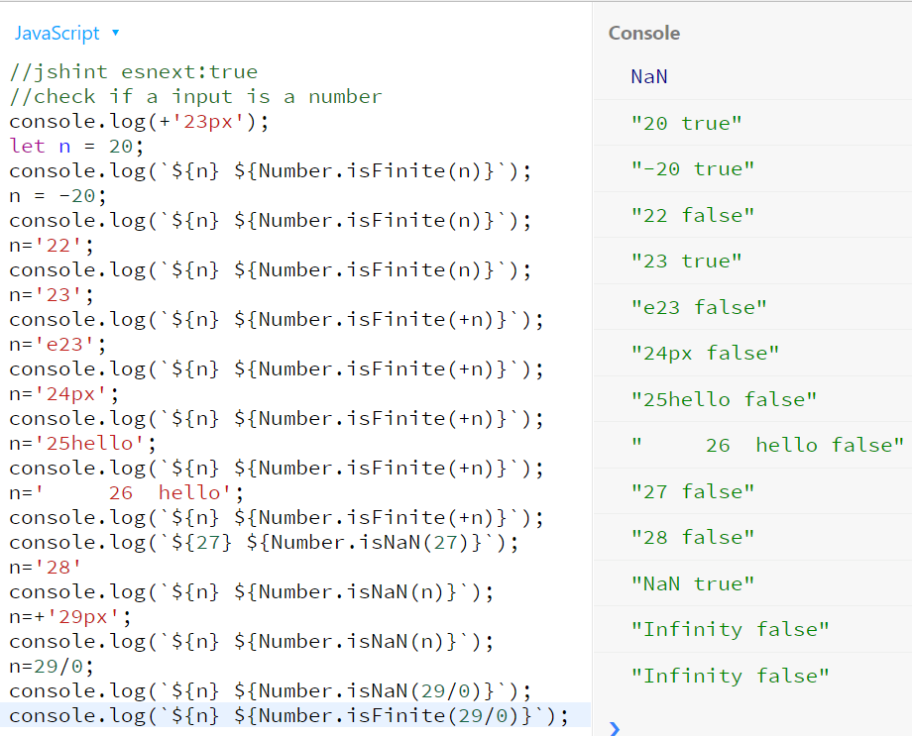

Example 3-> Number.isInteger

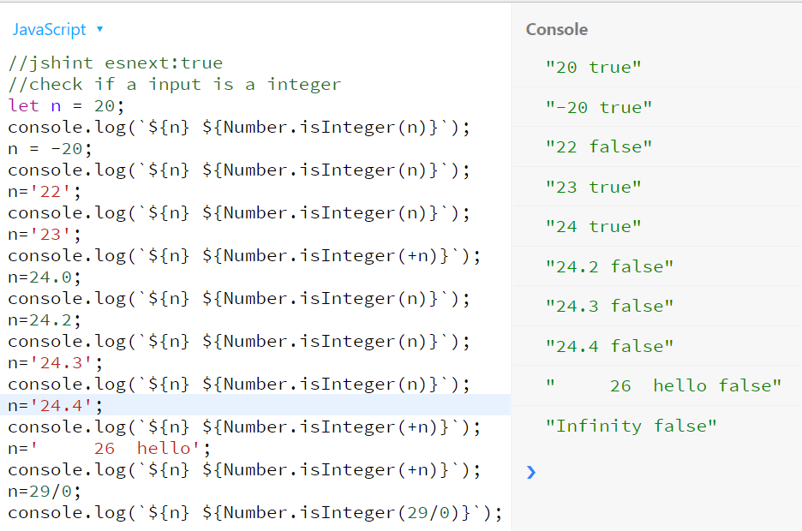

## 2. Math class methods

1. double * operator is used to calculate power of any input. Like 5**2=25

2. sqrt calculate sqrt of input passed. Which is equivalent to 25 **(1/2)

3. to calculate cube root 8**(1/3) can be used.

4. Math.max and min takes var-args as input and return max/min of all the input passed. It can also take number in a string. It return NaN if any of the var args cannot be converted into number.

5. floor method take input as number (string also works as it will do type conversion internally) and return integer and round to the lowest . ex -> 23.8 will be 23 and 23.3 will be 23.

6. ceil method take input as number (string also works as it will do type conversion internally) and return round result of upper limit. Ex-> 23.8 will be 24 and 23.3 will be 24.

7. round method return closest rounded result. Ex-> 23.8 will be 24 and 23.3 will be 23.

8. trunc method just blindly remove fraction part. Ex-> 23.8 will be 23 and 23.3 will be 23

9. difference between trunc and floor is that trunc always remove fraction but on other hand floor will return lowest value. for example Math.trunc(-23.5) = 23 and Math.floor(-23.5) => -24 ( as larger negative number is smaller).

10. toFixed method can be used to format decimal number to fixed number of fraction. It return string formatted output. Ex-> (2.3).toFixed(3) => 2.300

Example 1-> sqrt,**,max,min

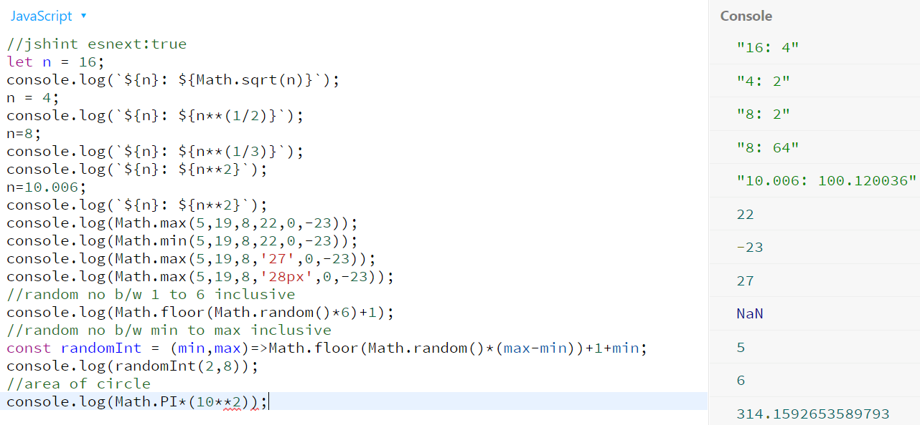

Example 2-> floor, trunc, ceil, toFixed method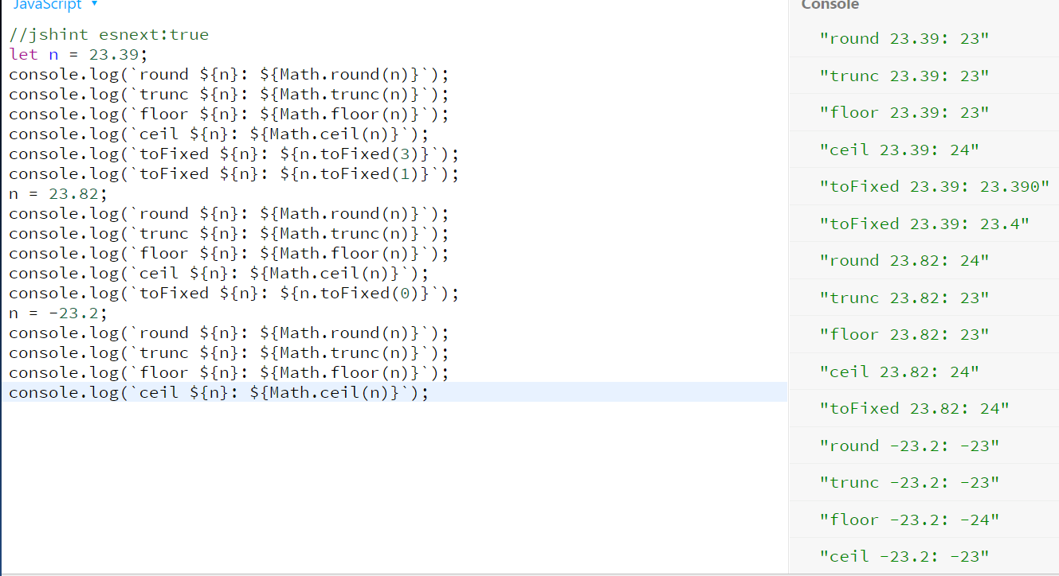

## 3. BigInt

1. In java-script every number is of 64 bit out of which 53 are used for number and remaining for sign and decimal points. So if a number needs more space then 53 bits we need to use BIGINT.

2. BIGINT are special data type and hence a bigint value cannot be added(no arithmetic operator) with other data type.

3. Math.sqrt and other function which are applicable for Number can’t be called with BigInt

4. suffix ‘n’ at the end of number to represent it as a BIGINT. E.g. -> 112223n

Example ->

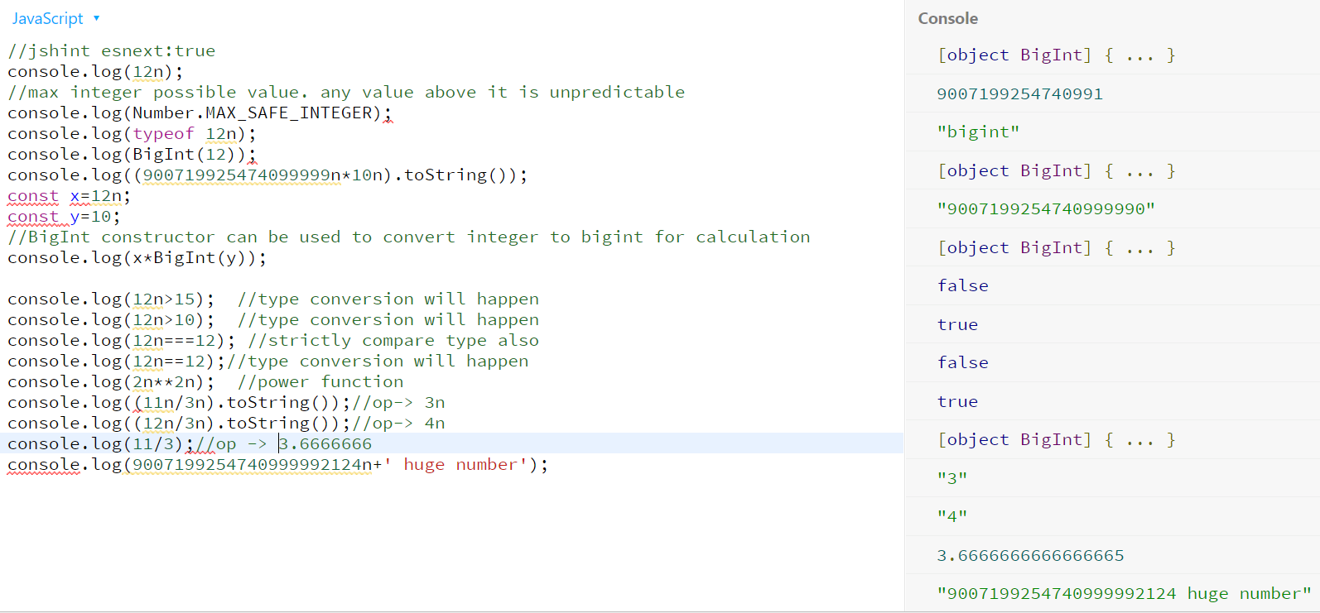

## 4. Date and Time

1. Date class provide various way to create and manage date in javascript.

2. all the date operation like +,- etc works internally on timestamp in ms.

3. new Date(timestamp) can be used to get entire date back from timestamp.

Example 1 ->

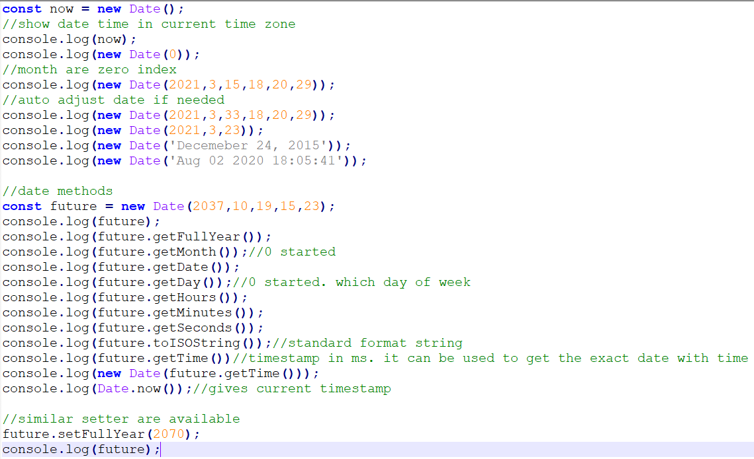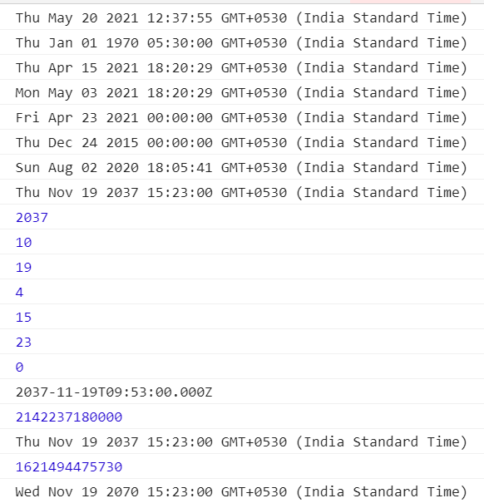

Example 2 ->

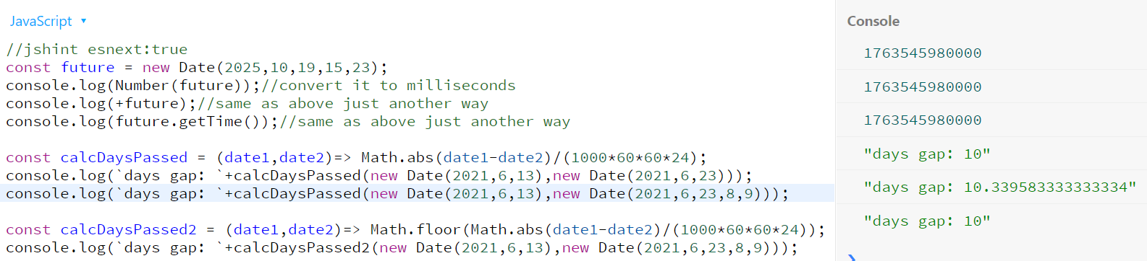

## 5. Internationalization Dates and Numbers(Intl)

Example 1-> Date

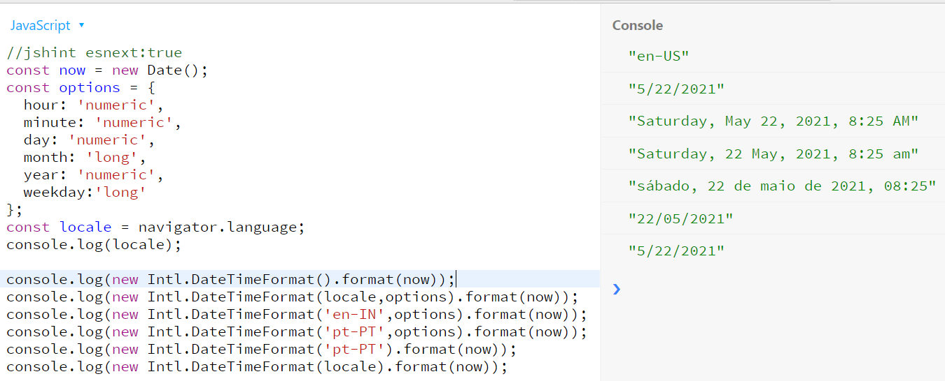

Example 2-> Numbers

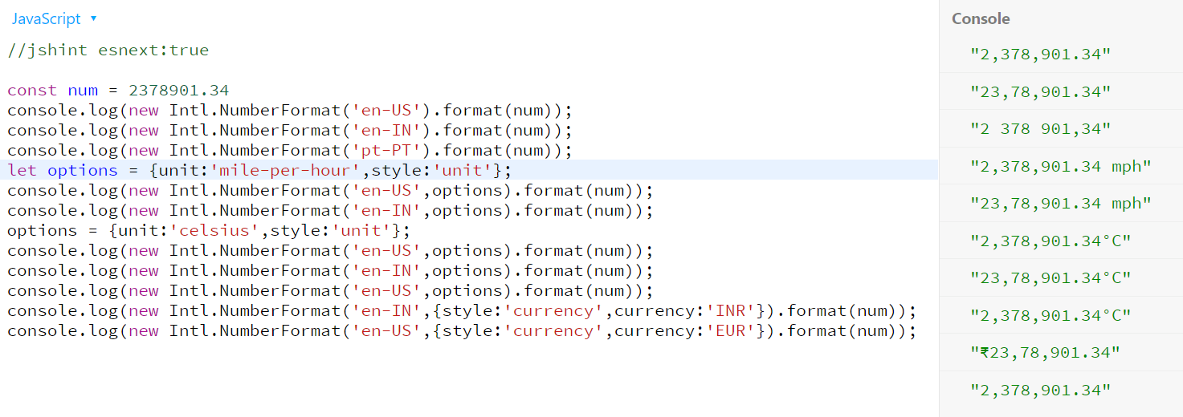

## 6. Timers

1. setTimeout takes callback function as first argument. 2nd argument decide time-interval in ms after which callback will be invoked.

2. if you want to pass any arguments to callback function it can be passed as varargs followed from 3rd argument onwards of setTimeOut function.

3. setTimeout return the timer object which can be later use if required. Like cancelling the timer callback execution.

4. you can also cancel timer callback function before the time elapsed by using clearTimeout function.

5. setInterval function can be used if same callback is needed to be executed repeatedly after fixed timegap.

Example 1 -> setTimeout , clearTimeout, clearInterval and setInterval function.

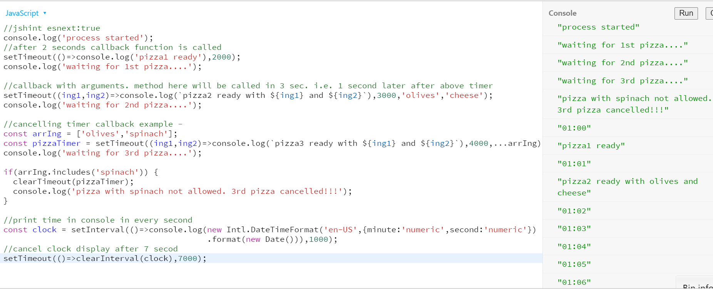

# Advanced DOM and Events

## 1. HOW THE DOM REALLY WORKS

1. DOM allows us to make java-script interact with HTML.

2. DOM tree is generated from HTML document. Which we can interact with DOM api.

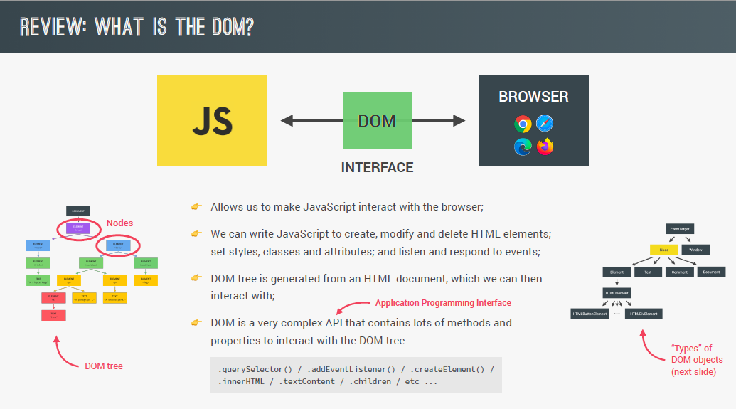

3. there can be different types of Node in a tree.

3.1 Element -> like <a><p> etc. each element is further sub-divided into specific category and hence specific methods like HTMLButtonElement has special button specific methods. And anchor tag has href attribute.

3.2 Text-> it is normal text. Like <p> hello</p> here hello is a Text

3.3 Comment -> anything under <!—comment--> is a comment

3.4 Document -> document is another type of node that has various useful methods that can be used in code like querySelector.

4. Every Node has method available addEventListener() . it is available via EventTarget abstract type (responsible for everything related to event) which is parent of every Node and also of Window object. Window has access to global object other properties which are not related to DOM tree.

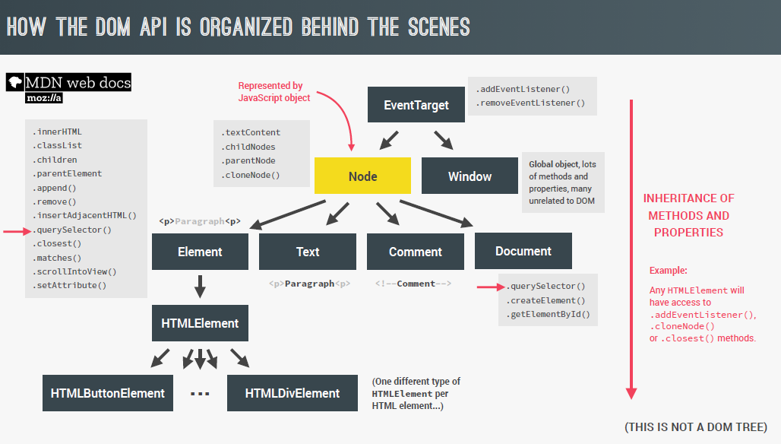

## 2. Selecting, Creating and Deleting Elements

1. document.documentElement will give access to entire html

2. document.head and document.body will give head and body of html page.

3. methods like document.getElementsByClass and document.getElementsByTagName will return the HTMLCollection object. Which will maintain live collection of data. Ex-> It means we don’t need to retrieve again and again to get current buttons. Suppose initially we have 9 button. But after storing them in a variable ‘test’ one button has been removed. So now test will automatically contain 1 less element. We don’t need to call document.getElementsByTagName(‘button’) again to get updated list.

4. insertAdjacentHTML method can be used to insert html adjacent to object on which it is called. Like –

containerMovements.insertAdjacentHTML("afterbegin",htmlString);

5. just like insertAdjacentHTML method like prepend and append also exists. Header.prepend(documentNode) will add documentNode to starting of the header document. While append add it to the last.

6.cloneNode(true) will clone the current document along with childs(as true is passed).

7. header.before and header.after will add before and after the header.

8.

Example 1-> Select elements.

Input 1->

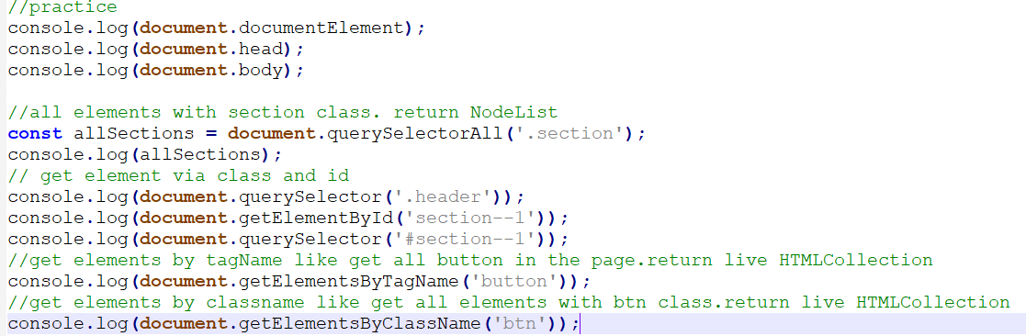

Output 1->

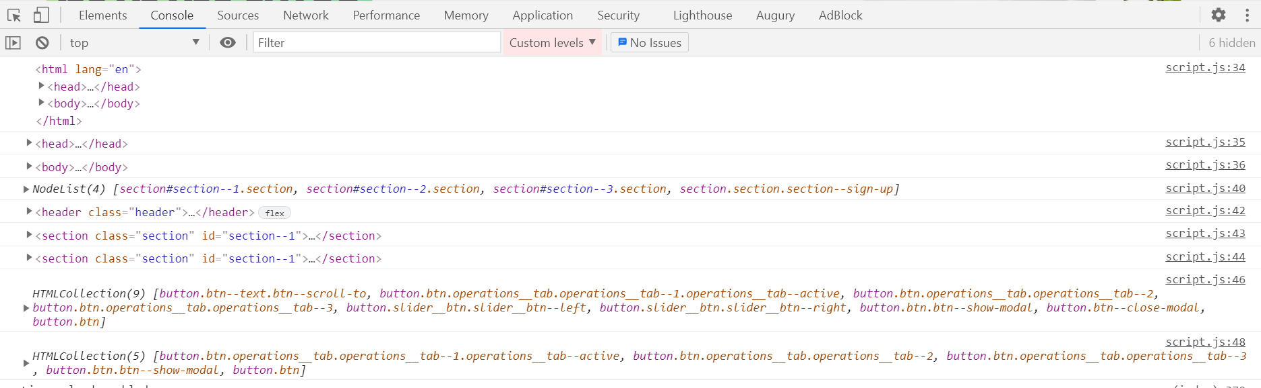

Example 2-> creating and inserting elements

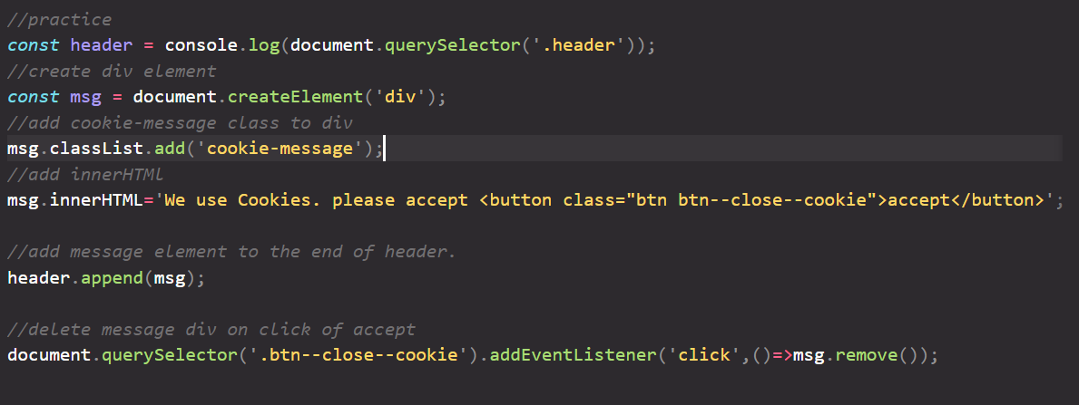

## 3. Styles, Attributes and Classes

1. Every Element has style attribute which can be used to provide inline style. Ex->

Message.style.color = ‘red’

2. but we can read only those style which we have not set via js code only use style attribute. If you want to access style return in html and css also for a particular element use getComputedStyle(message) method.

Ex-> getComputedStyle(message).color

3. element.setProperty(key,value) can be used to set some value associated with a key and which is available and associated with element.

4. attribute is the fields of the element. For example -> img tagelement has src and alt attributes.

Ex->imgElement.src can be used in js.

We can also set extra attribute which are not directly part of imgElement. Like imgElement.setAttribute(‘designerName’,’kush’);

5.imgElement.url will give complete url and if we want relative url we need to use imgElement.getAttribute

6. to add,remove,toggle and contains classes in element. Use classList field

message.classList.add(‘className’);

message.classList.remove(‘className’);

7. message.class=’hello’ will remove every class and just assign hello class to message element.

## 4. Types of event and event handlers

There are 3 different to attach event and handler to the element

1. using addEventListener method.

2. using onEvent attribute of element itself. Like onclick, onmouseenter etc

3. using html tag present inside html itself via same onclick attribute.

4. first way should be preferred as we can then use removeEventListener method to remove listening to event.

Example -

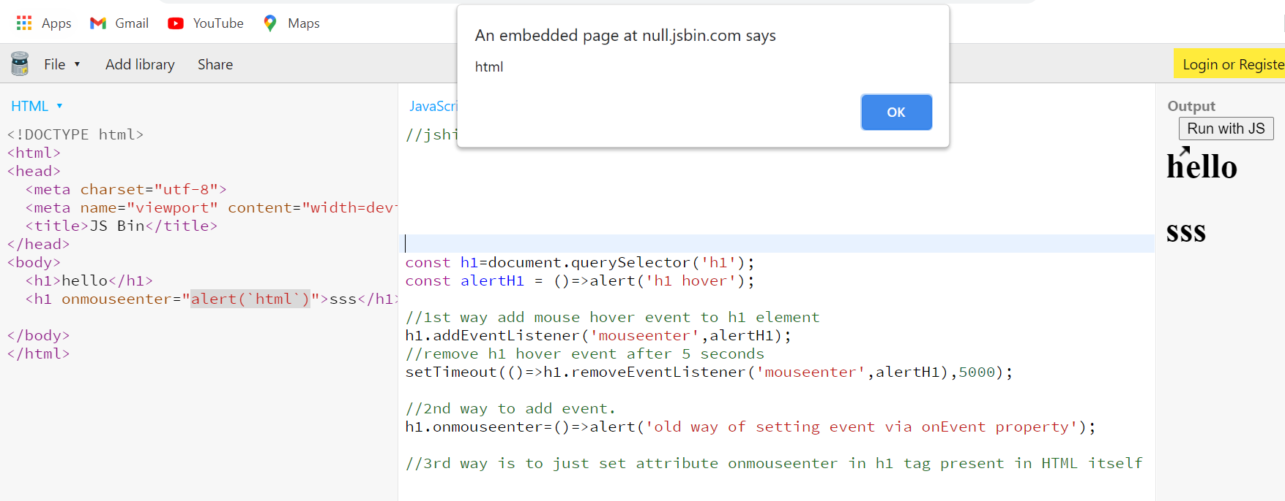

## 5. Event propagation: capture and bubbling.

1. first is capturing phase where on event first it happens on document and then it propagate down to the actual target child which has provided handler to handle the event.

2. On target it is handled and then propagated back to parent till root. This is called bubbling phase. Bubbling up is just like that particular event happened also at that particular element itself.

3. If we have attach handler to any parent also including the intended target element. Then it will also get executed from bottom to top fashion.

4. same event object is forward in bubbling phase up to the hierarchy and event.target will always point to the element on which actual click has happened and will be same. If we want to know current element on which event has happened in each respective handler, Use event.currentTarget property Or this keyword.

5. For most of the events like click it works like that but for some events there might be directly target phase executed.

6.by default handlers are attached to bubbling phase not to capturing phase but we can add event listeners in capturing phase also by passing third argument to addEventListener method as true. By default thrid arg is false.

By this instead of calling handlers in bubbling phase starting from target phase, the order will get reversed entirely. And first handler of parent will be invoked followed by child till actuall target on which click has happened.

e.g-> msg.addEventListener(‘click’,e=>console.log(e.target+’,’+e.currentTarget),true);

7. to stop event propagation just call the event.stopPropagation() method in handler. It will stop remaining handlers to get executed.

8. handling event at capturing phase is rarely used.

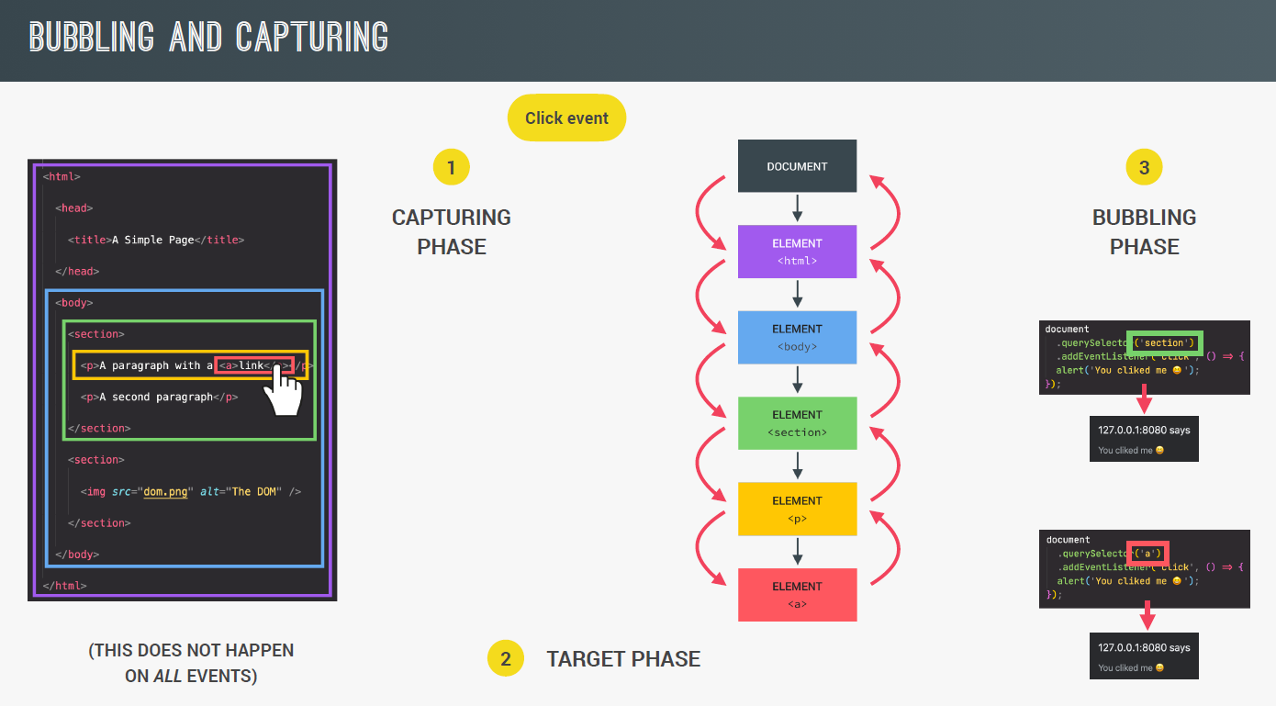

9. we can use this feature of event bubbling like suppose there are 5 li items inside ul. So we want same code to be executed for each li click. So instead of calling foreach method and addeventlistener to each of them we can assign addEventListener to ul only. And inside handler we can get the actual li item click via event.target.

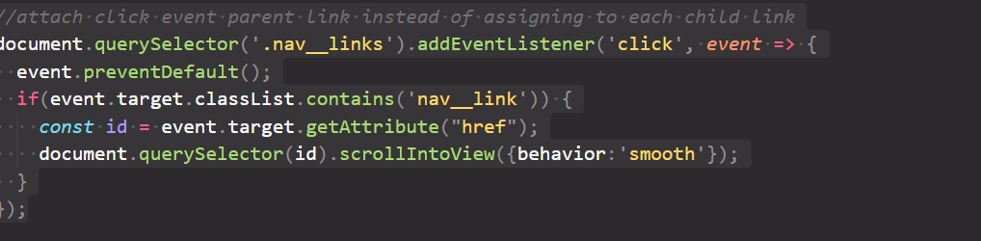

## 6. DOM Traversing

1. by using different methods of dom we can go upward, backward, left and right of any element.

2. in-practice use element related methods not node related methods. (don’t memorize these method as they are hardly used accept closest and children)

Example 1-> downward

Always prefer element.children to get list of children elements as childNodes will includes all nodes not just elements.

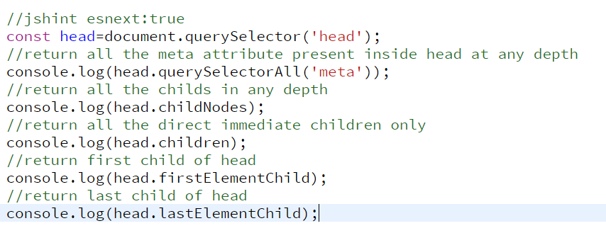

Example 2-> upward

Closest method return the nearest parent of the element with specific class or id. if itself has that class it will return itself. It is just opposite of querySelector.

As query selector searches the nearest child of the element with specific class or id.

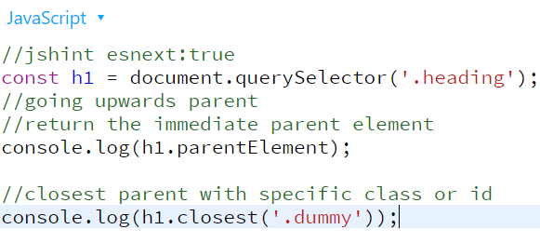

Example 3-> sideways (searching siblings)

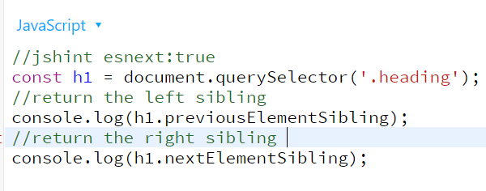

## 7. Intersection Observer API

1. this api allows code to observe changes when target element intersect with other element.

2. first create object of IntersectionObserver. It takes two arguments. First is the callback function which will get invoked once intersection happens. Second is options object which will decide which is the root element on which we want to start observing intersection and threshold array to decide percentage at which when overlapping exists callback method should be invoked. entry object of callback will have isIntersecting field true while entering the intersection with desired threshold overlapping and will be false while leaving that threshold value.

const obsCallback = function(entries,observer) {

entries.forEach(entry=>console.log(entry));

}

Const obsOptions = {

root: null,

threshold: [0.10]

};

const observer = new IntersectionObserver(obsCallback, obsOptions);

observer.observe(section1Element);

3. via observe method we pass target element on which intersection we want to observe with root element passed in options. If root is null then entire viewport is considered.

4.if in options entries array contains two values like [0,0.10] then it means callback will be called with isIntersecting field true when either 0 prcnt intersection happens or 0.10 percent both while entering and leave the section1.

## 8. Some useful DOM Events and there Life Cycle

1.DOMContentLoaded event. It is fired after the html is parsed and dom tree built. So if we want something to be executed after initialization of dom tree is done we can write it in callback of this event. In jquery it is equivalent of document.ready function. In general we write script tag as the last element of html body element. Hence everything written inside script.js will be executed automatically after dom tree is created. So in such case we don’t need such event.

2.load event we can use to execute some code after specific element is loaded. In case of window.addEventListener(‘load’,e=>console.log(‘dom loaded’));

After the dom is loaded the callback will be executed.

3.sometimes in application where user is filling form we want to prevent accidently close of browser window or accidently refresh. For that we can use beforeunload event on window object. In such case prompt will be shown asking user to stay on page or leave.

Example ->

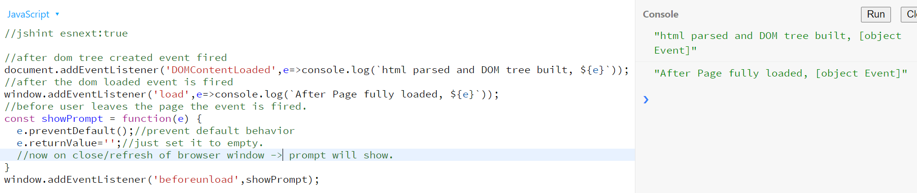

## 9. Efficient Script Loading: defer and async

1. Never put script tag in head directly. As we want script to be executed only after html is parsed.

2. defer and async can be used if we want to use script tag in head. For detail explanation of difference see diagram.

3. async allow loading of html and parsing of html parallelly and once script loaded browser stops html parsing and execute script. Once script execution done browser continue html parsing.

4. defer allow loading script and html parsing parallelly but script will be executed only after html parsing complete.

5. async and defer make no sense if we add them in script tag at body end. As her html is already parsed.

6 async head, defer head, head and body end they all have there use-cases and should be used accordingly.

7. defer and async are feature of html5 and hence old browser which does not support html5 will ignore these attributes.

**Note**-> global variables are available to all scripts after which it is declared.ex-> if global variable ‘a’ is created in scripta.js and ‘b’ is created in scriptb.js. and in head/body scripta is included first then scriptb. In such case scripta will not have access to global variable declared in script. But script can access both.

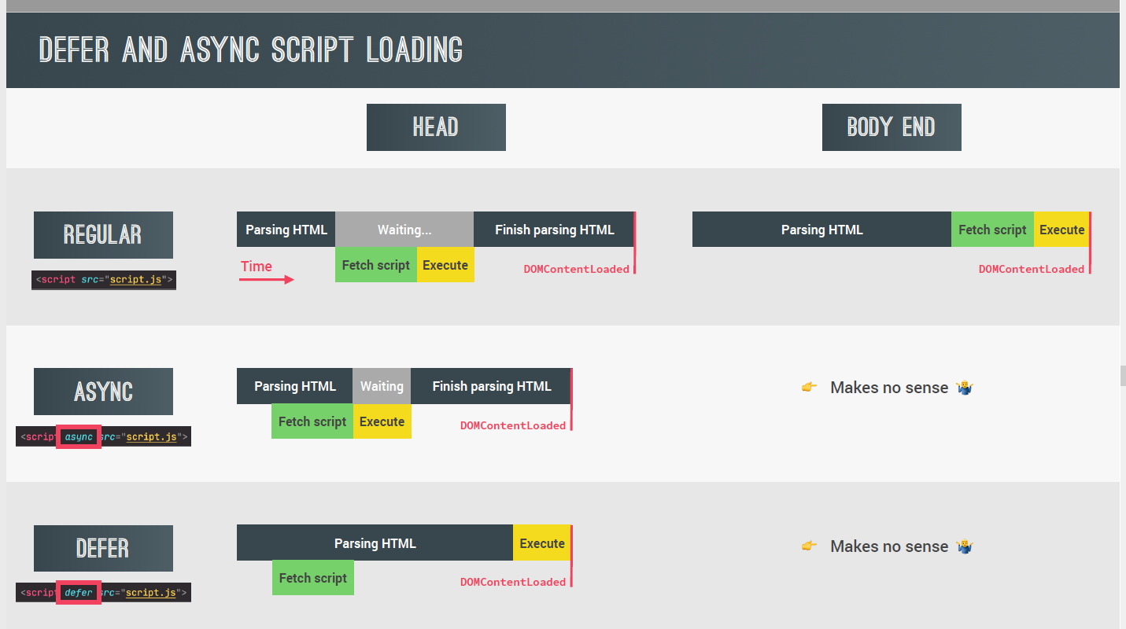

Difference between regular vs async vs defer

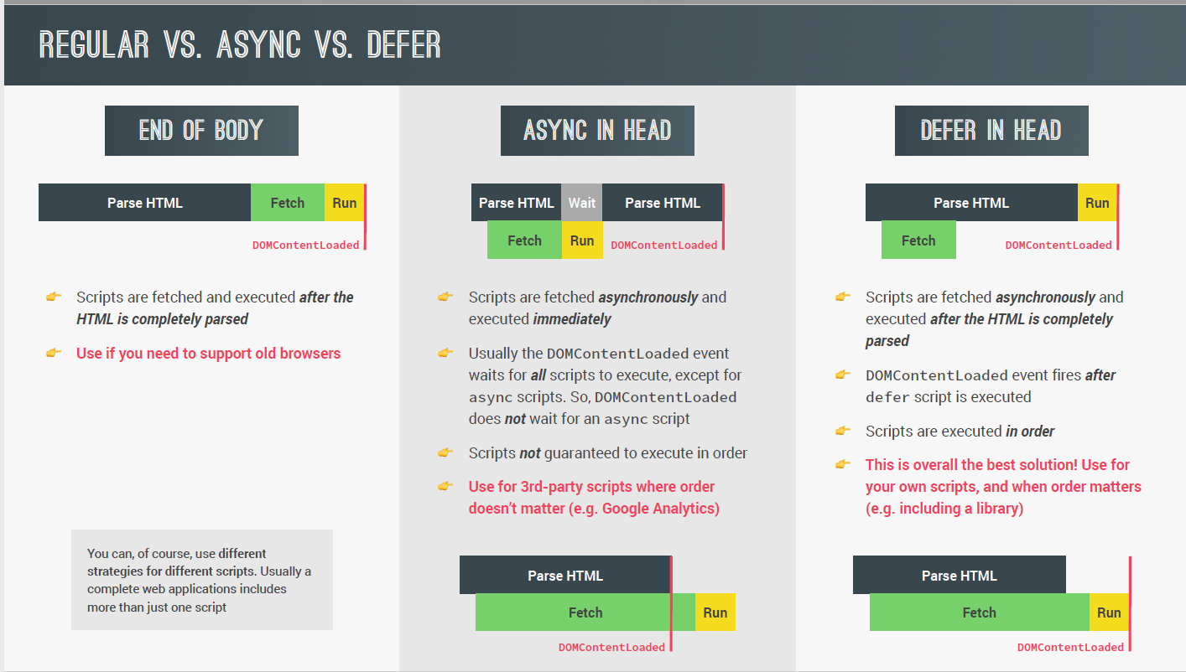

# Object Oriented Programming

## 1. OOP in general

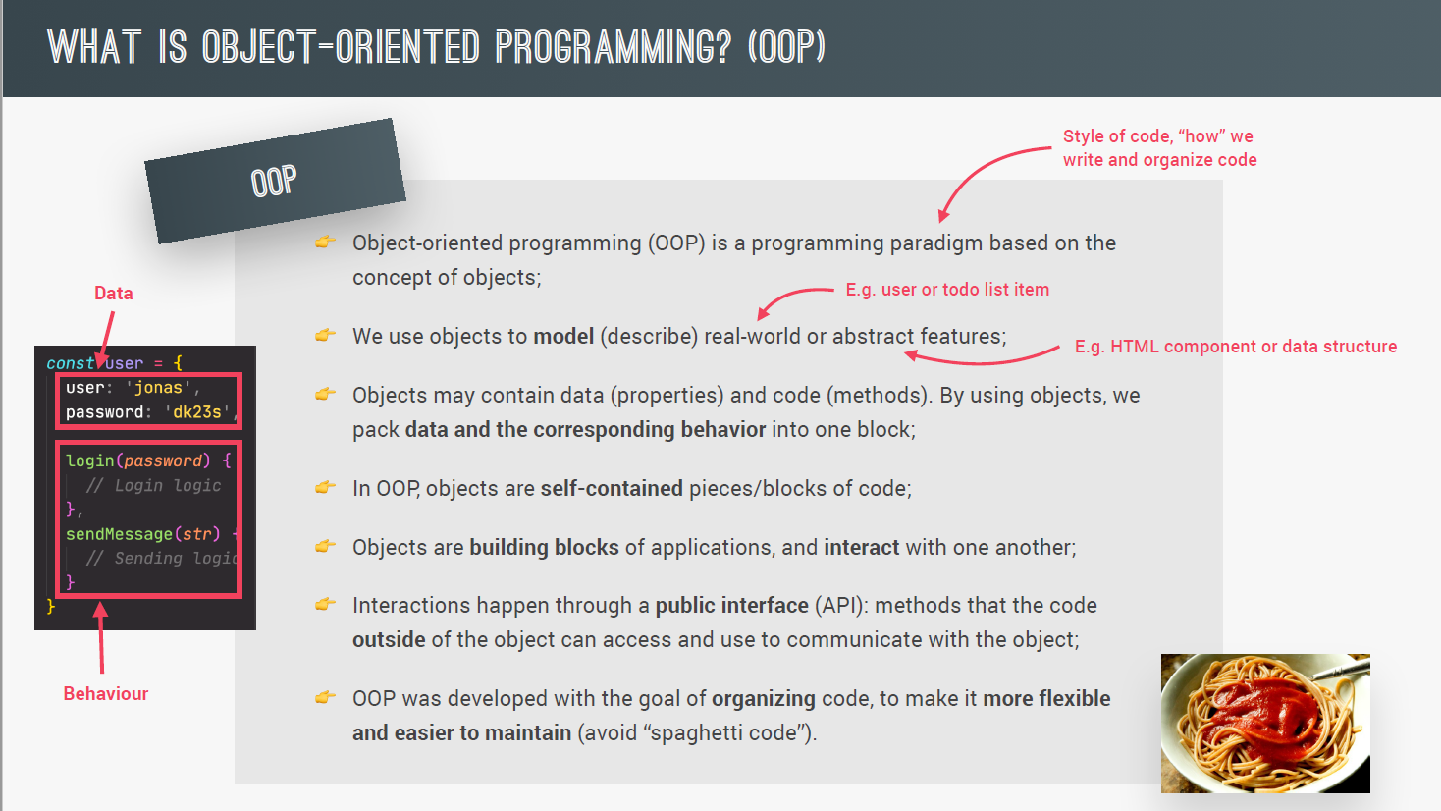

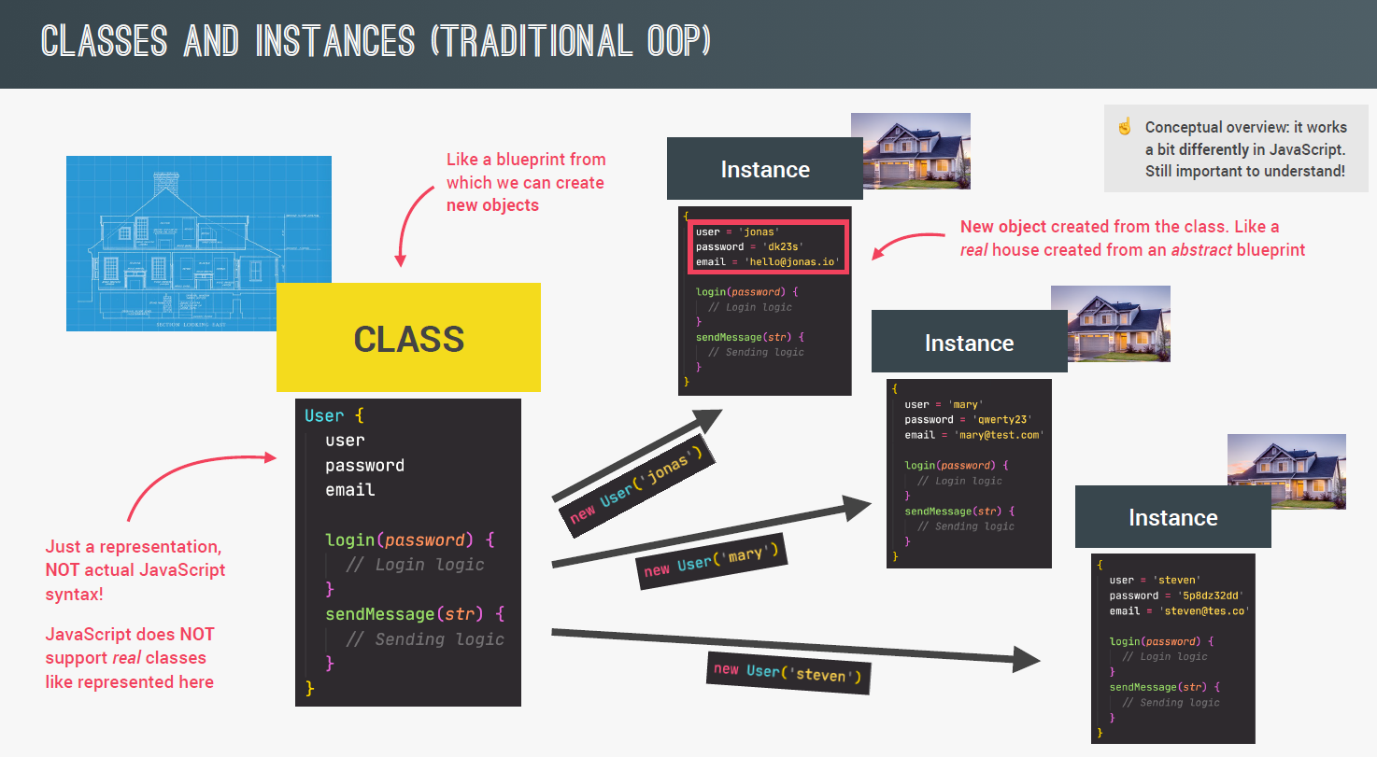

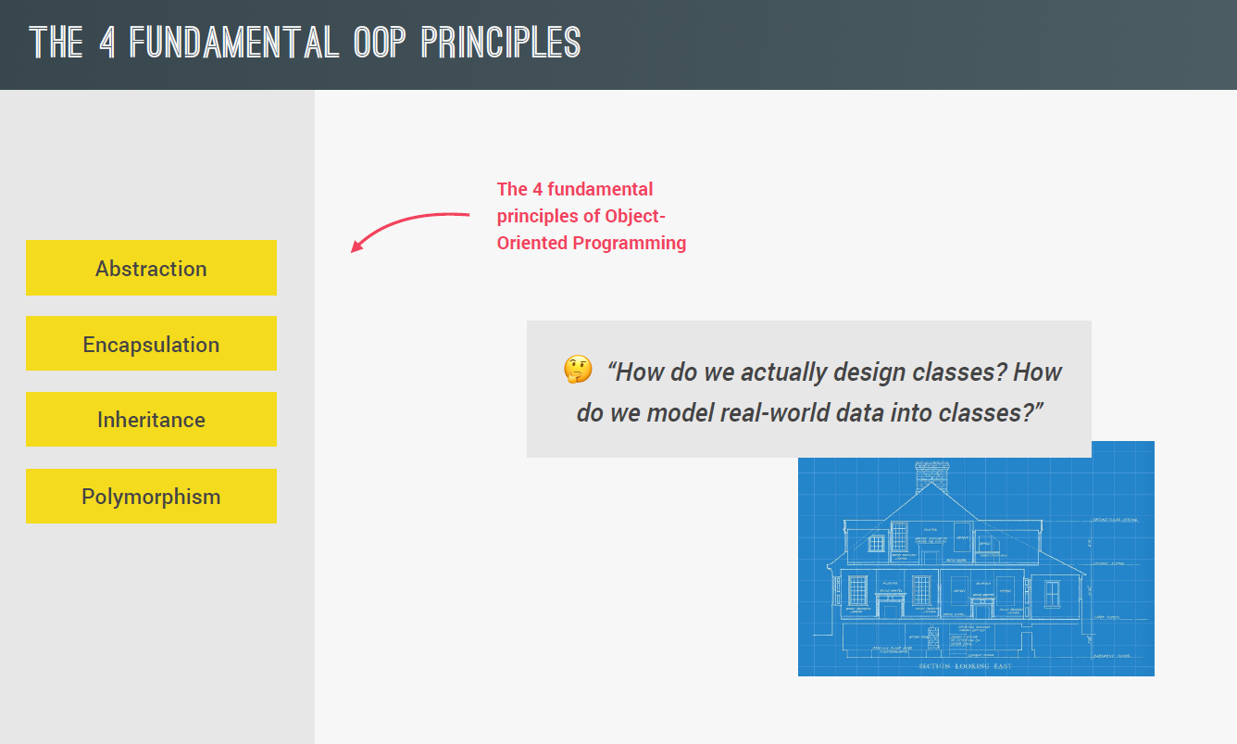

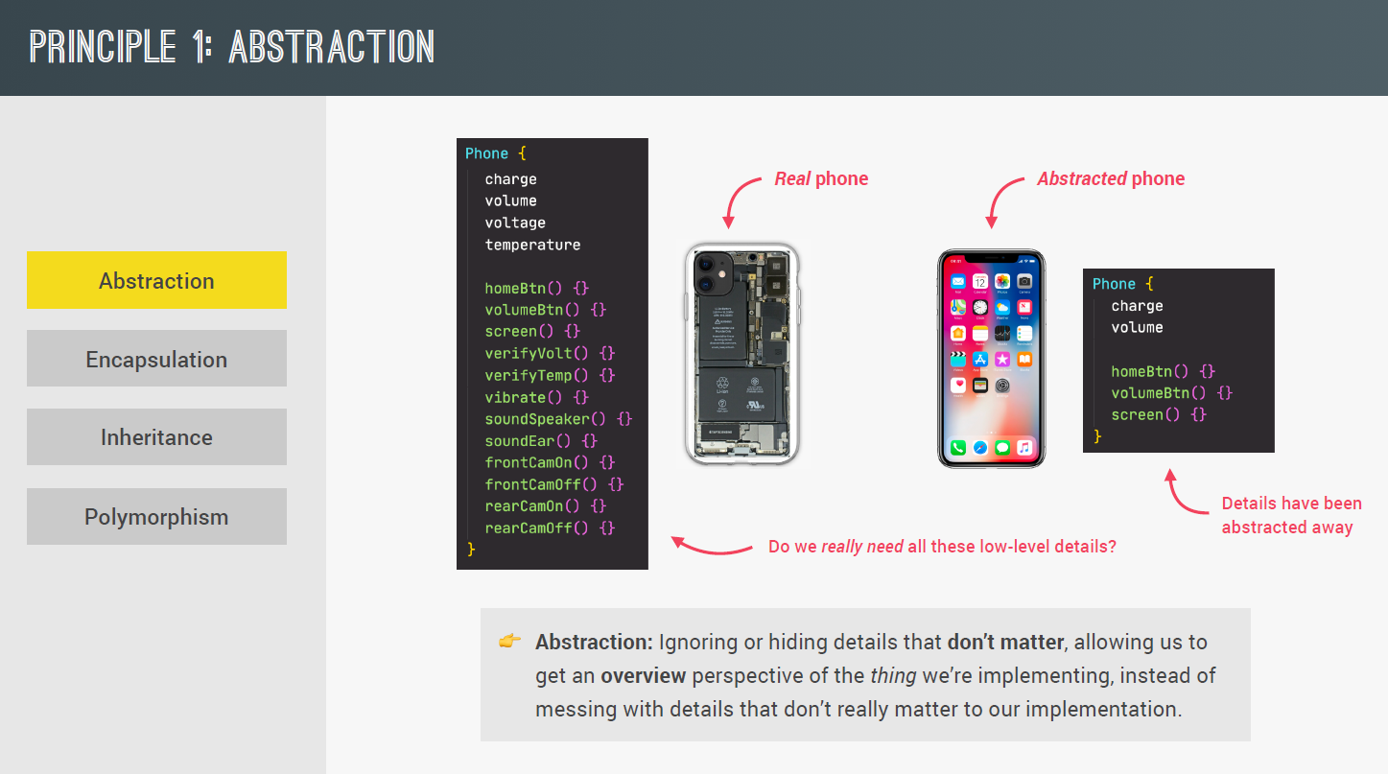

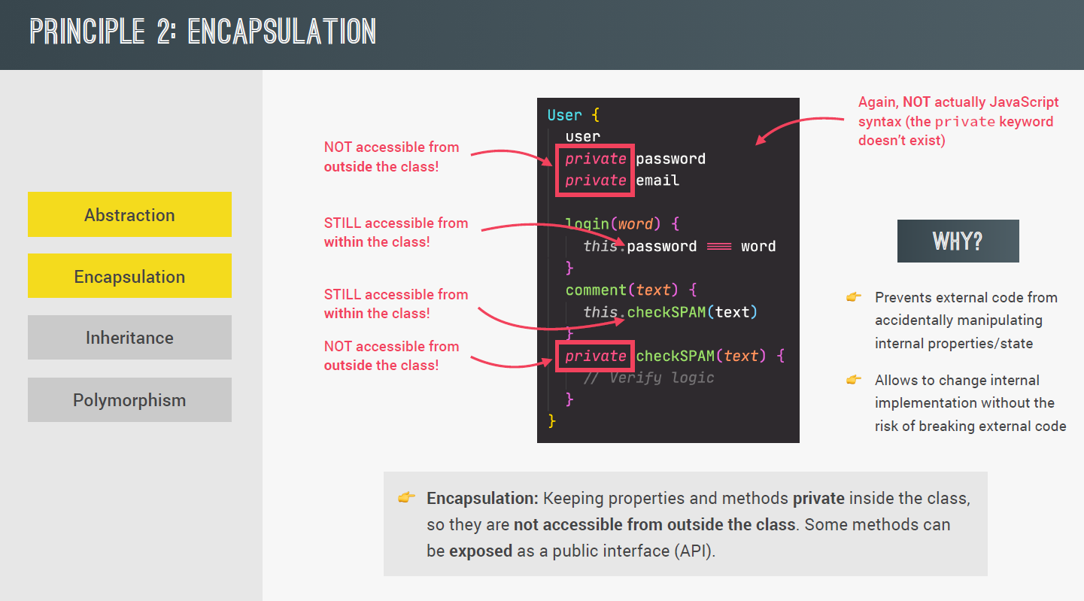

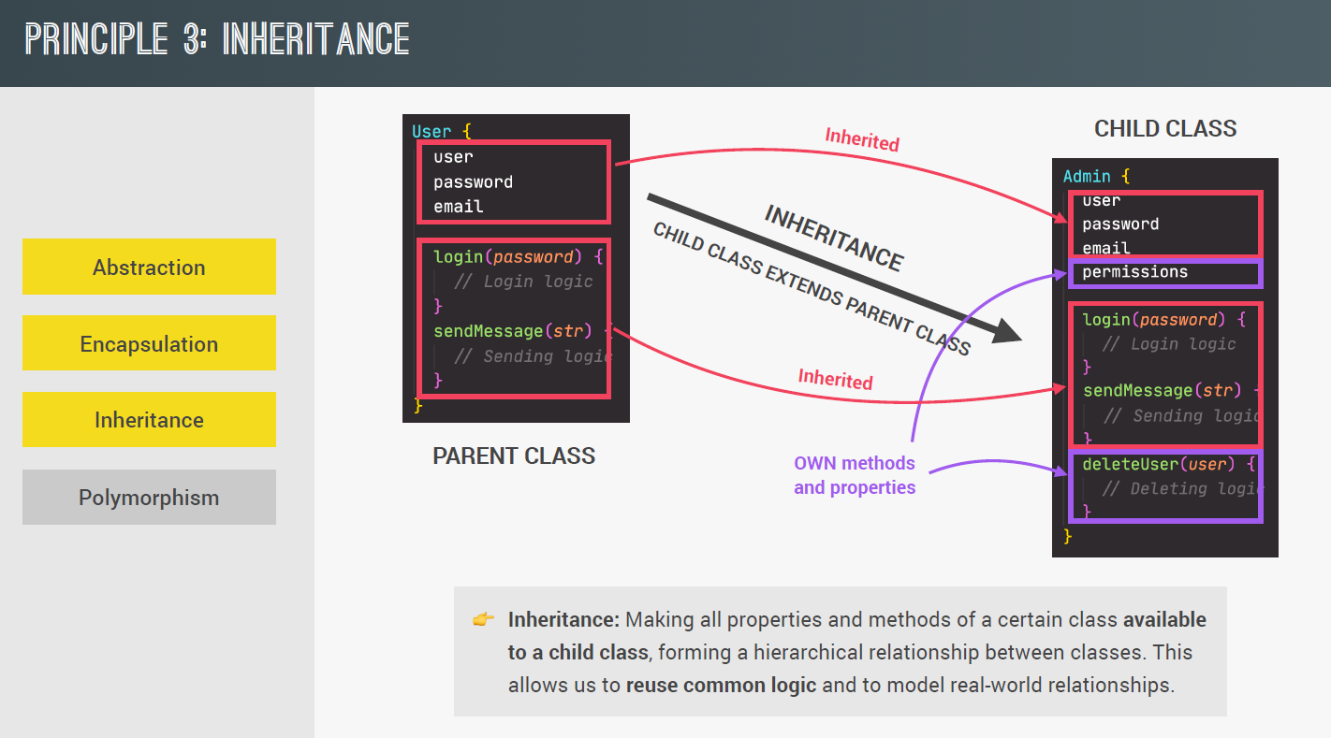

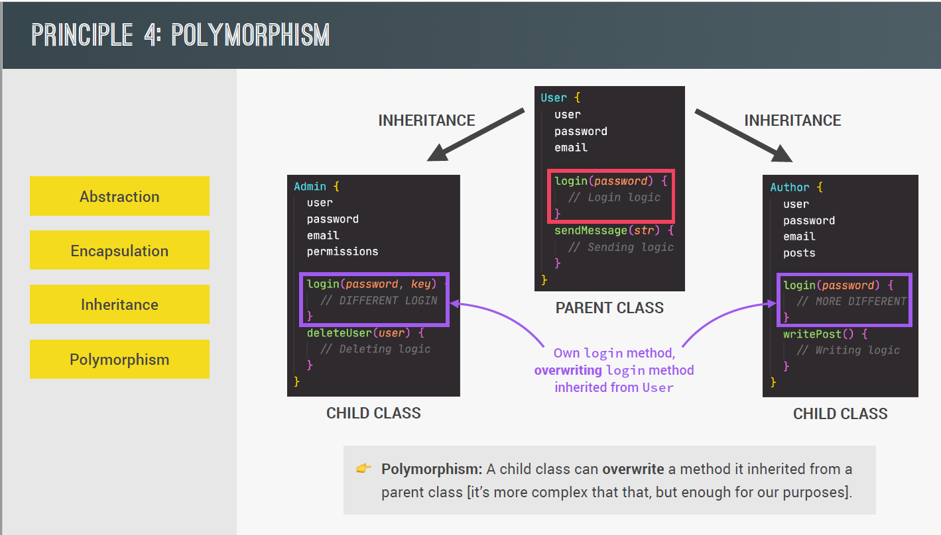

## 2. OOP in JavaScript

1. in javascript prototypal inheritance exists. Which means there are methods created in prototype and all the objects will have access to those method via prototypal inheritance. Example->

const num =[1,2,4];

num.map(x=>x*2);

here num array gets map method via prototypal inheritance. Array.prototype is the prototype of all the array objects. Hence num array also linked to prototype. And via Array.prototype.map method num array got access to map. so we can see that here num just calling/delegating to Array.prototype map method. map method is not part of own num array but part of its prototype which is Array.prototype here.

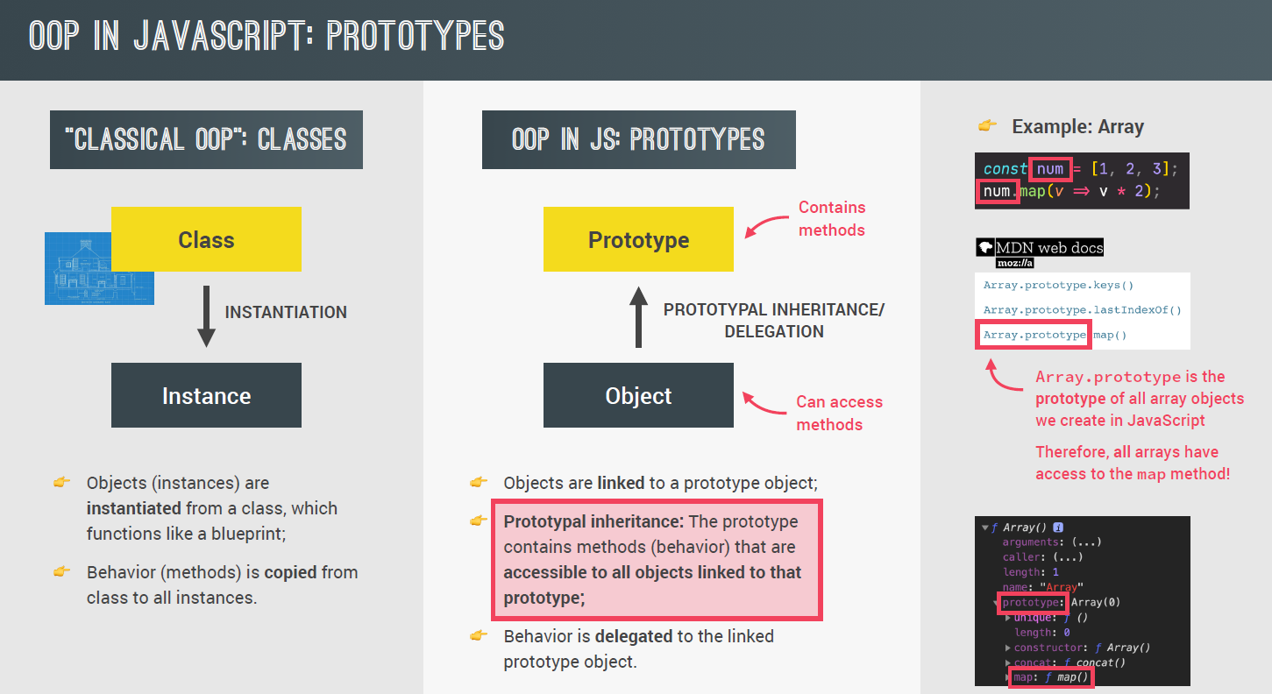

2. Different ways of implementing prototypal inheritance->

* **Constructor function**-> it is technique to create objects from functions. This is how built-in objects like Arrays, Maps or Sets implemented.
* **ES6 Classes->** It is a modern way to constructor function syntax which internally works exactly like constructor functions. Just it is easy to implement as a end-user.
* **Object.create->** via create method we can link object to a prototype object.

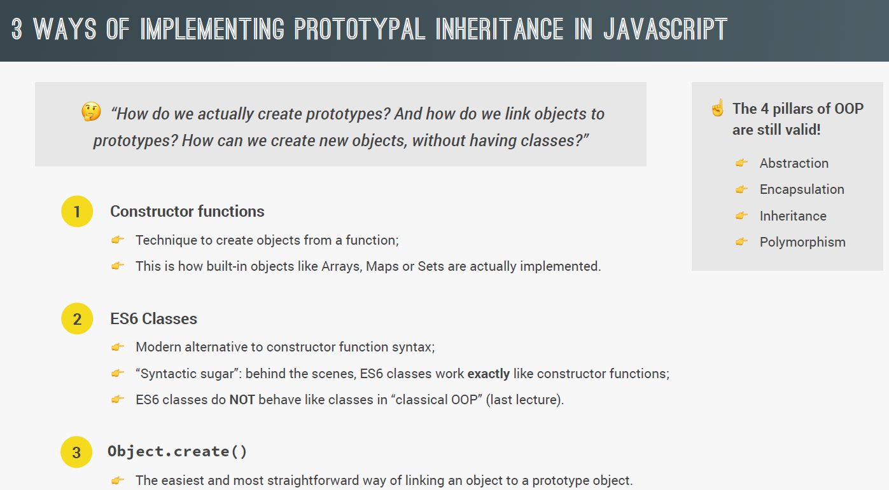

## 3. Constructor functions and new operator

1. constructor is just like an ordinary function just we call it via new keyword

2. As a practice we assign it to a variable with first letter as Capital and we does not write constructor function in lambda. As lambda does not have this keyword.

Example of Constructor function->

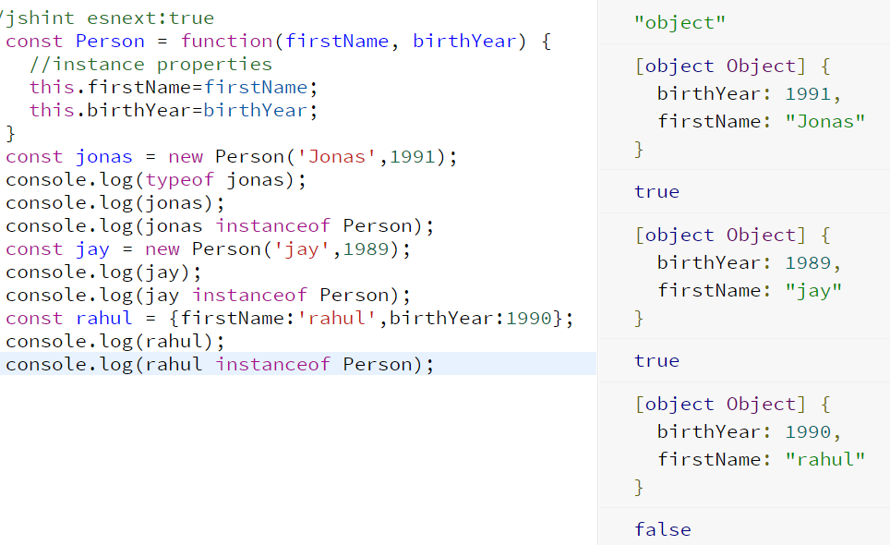

**3. Steps followed when we call constructor function via new keyword->**

* New empty is created . {}
* Function Person is called and same empty object {} is set to this for this function call.
* Empty object is linked to prototype
* Function will automatically return this object which is passed.

**It means whatever we assign to this variable inside body of function will be available to us via returned object.**

4. Via same constructor function we can create as many objects we want. It serves as the blueprint to create Person object.

5. We can also write instance method inside constructor function like below but in such case every object will have same exact copy of method inside them which we should avoid via prototype. Same way Array class has added various methods via prototype. As a practice never add method inside constructor function.

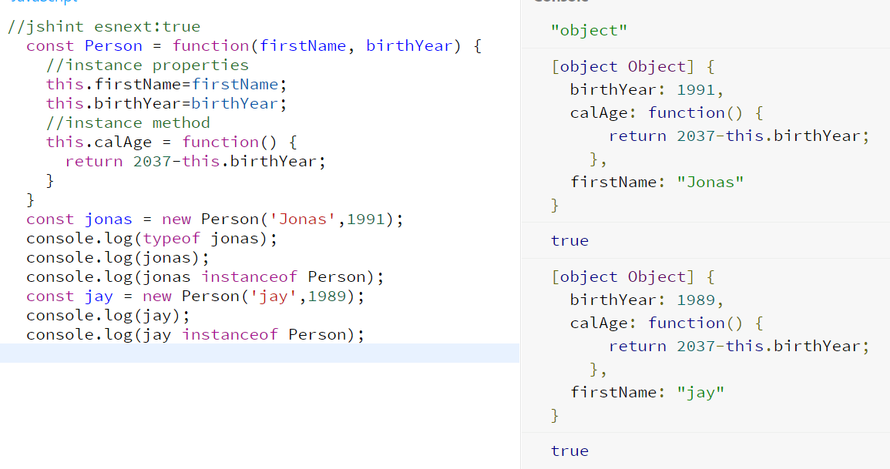

## 4. Prototypes

1. every constructor function has prototype property set with some object. and every object created via constructor function will have access to prototype object. Which can be used.

2. We can assign method or variable to prototype of constructor function at any given point. All the objects created via constructor function will have access to that prototype method even if they are created earlier.

3. Child objects will not have prototype method as part of there structure. Internally child object uses __proto__ property which point to the prototype of parent class. And hence child will have parent prototype method available.

4. For parent i.e. constructor function prototype is just like a normal field which will be available to all child via __proto__ field. Parent constructor own __proto__ field is not same as its own prototype. ( it points to its own parent if present else to Object.prototype)

5. if we assign some fields instead of method to constructor function prototype property, it works well just like method but the difference is inside field this variable is not that empty object which is passed.

Example1 ->

Input->

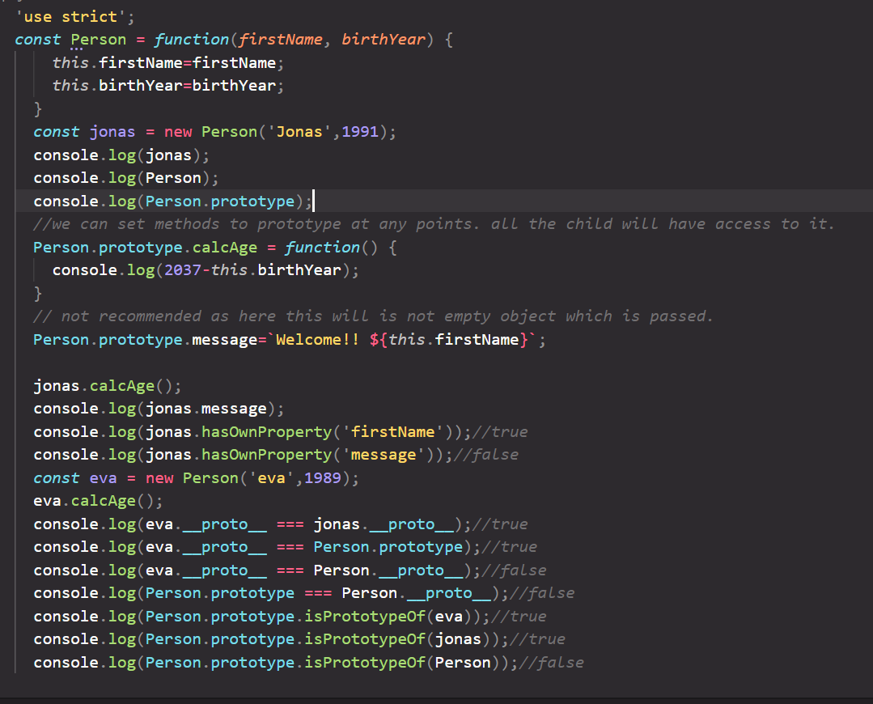

Output->

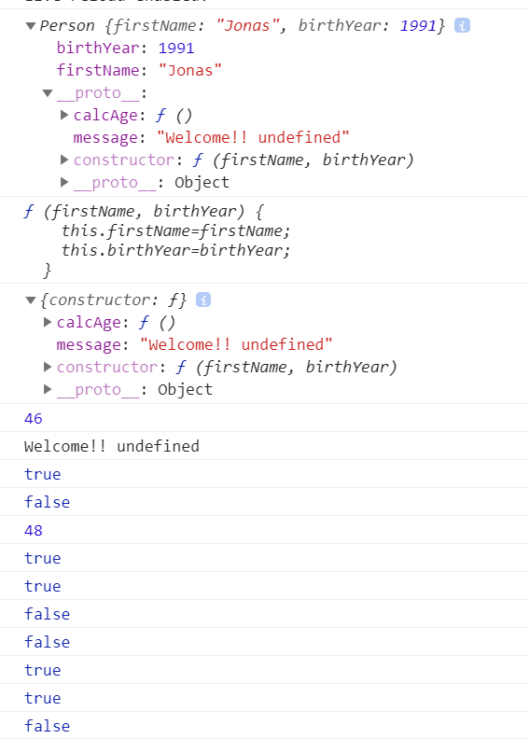

## 5. Prototypal inheritance and chaining works->

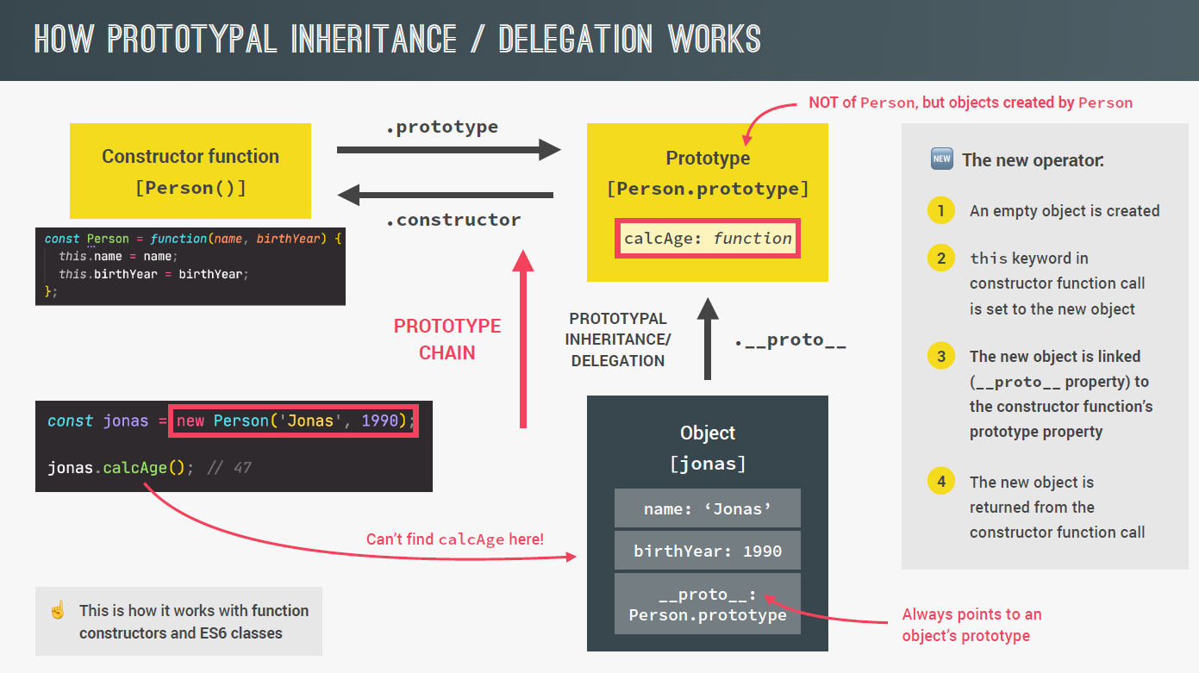

1. Person __proto__ will point to the Object.prototype. and Object __proto__ Is set to null. So when suppose on Jonas object we call hasOwnProperty method it is checked in Jonas itself if not found it searched into __proto__ which points to Person.prototype. If Person.prototype also does not contain method it is searched to Object.prototype via Person.__proto__

2. it means every object weather it is created via {} or new Object way has __proto__ to point to Object.prototype. and hence access to all the methods of Object.prototype.

Example ->

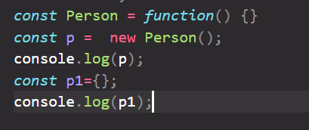

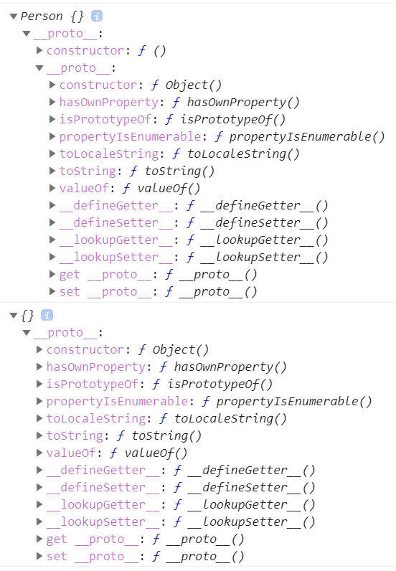

3. prototype chaining ->

3.1 we can also write jonas.__proto__.__proto__ . it gives Object.Prototype.

3.2 when we create array like const a =[2,4] or via new Array(2,3,4); is __proto__ property will be linked to Array.prototype and hence all the methods like concat, fill, filter, map etc are available to array object via Array.prototype methods. Example ->

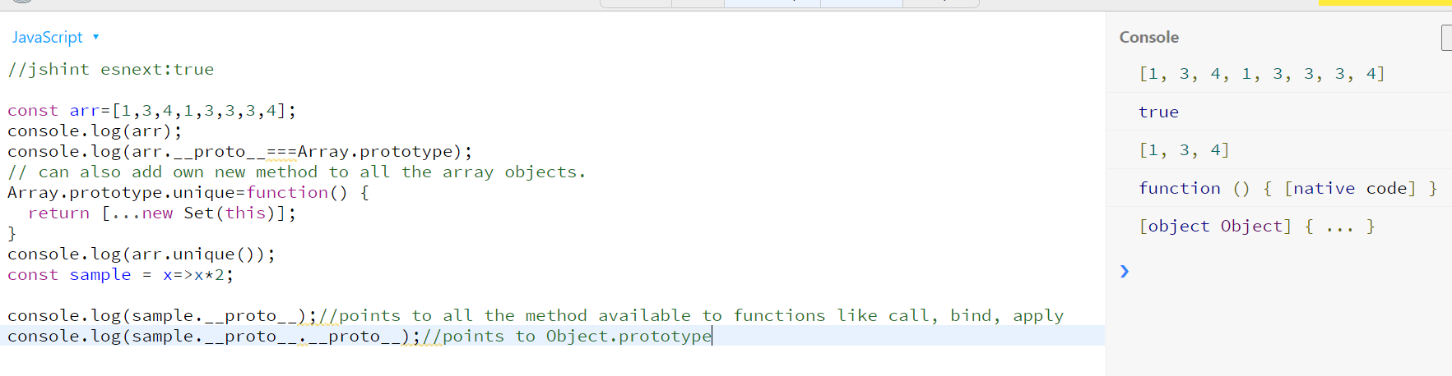

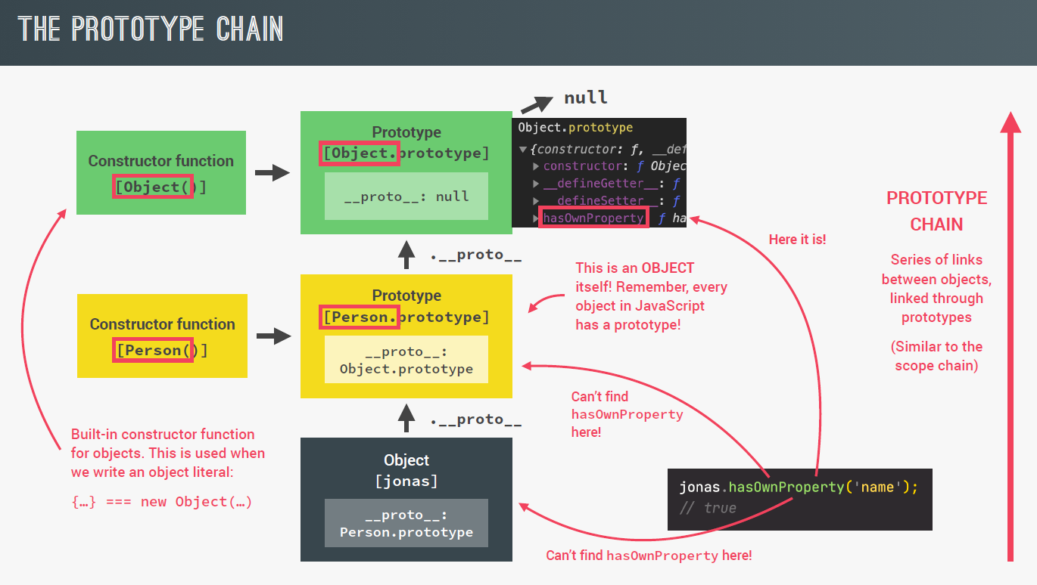

## 6. ES6 classes

1. it is extension of constructor functions by removing some boilerplate code for us.

2. we use class keyword and inside it we right constructor keyword which take args just like constructor function.

3. every method created inside class and outside constructor will be added as prototype of that class.

4. object will be created in a same way as it was done in traditional constructor way.

5. classes are not hoisted. It means they are not moved to the top just like function declaration.

6. classes are first class citizen. It means can be passed as argument or returned from function.

7. classes are executed in strict mode. It means even if we have not written strict mode. Code inside class is by-default work like strict mode is on.

Example 1-> create es6 class

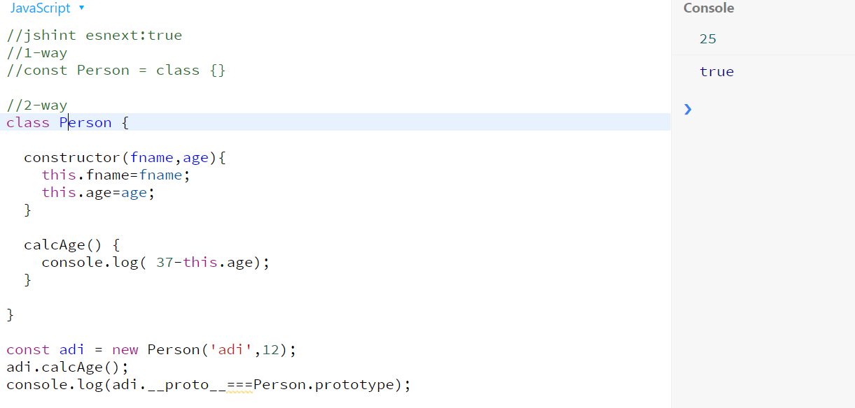

## 7. Getters and Setters

1. getters and setters can be used in normal object as well as inside es6 classes.

2. If we want to make method work to work as getter/setter property, they can be used.

3. it is not mandatory to add both in normal object.

4. similarly we can write getter and setter in es6 class also. Just make sure constructor should not be calling that setter. In such case infinite call will happen. Example if in constructor this.age= 24, is used then if we have written get age and set age method then error will occur as constructor itself is calling setter for age.

Correct Example ->

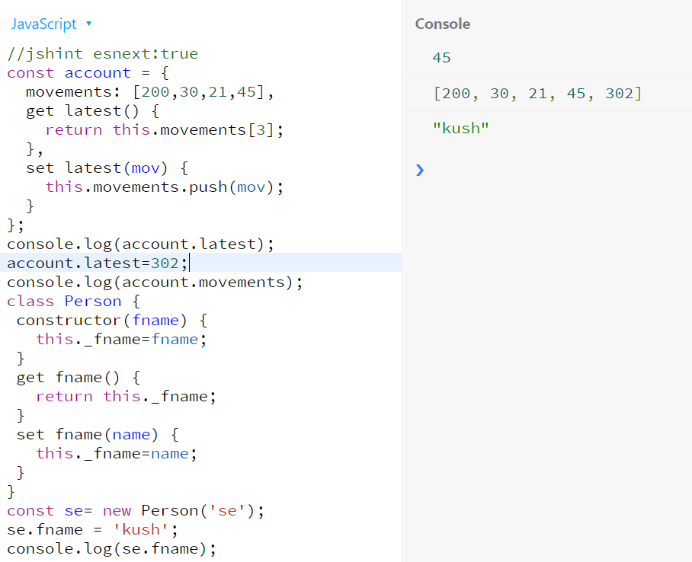

## 8. static method

1. we can also add static method which is specific to constructor class only not dependent on objects. Such type of methods are not attached to prototype and hence child cannot call them via dot operator as in case of normal method. it is just part of Parent class and can be call via Parent.methodName().

2. Number.parseFloat(12) method is example of static method. on normal number object it will give error.

Like -> 12.parseFloat(2) will give error.

3. we can write own static method in constructor function and ES6 class.

4. this inside constructor function point to whole function and inside class to entire class. Hence not useful.

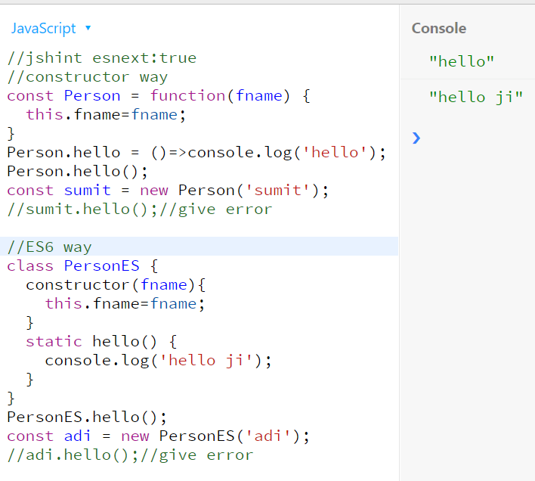

## 8. Object.create

1. in a normal object if we want to assign any other object as prototype we can use Object.create(prototypeObject).

It will create an empty object and assign passed object as prototype and return it. After that you can add some fields to returned object manually if needed.

2. this approach is less used as compare to constructor function and ES6 classes as we need to explicitly assign data to fields for each object. And this can happen after Object.create returned the empty object with prototype set.

Example ->

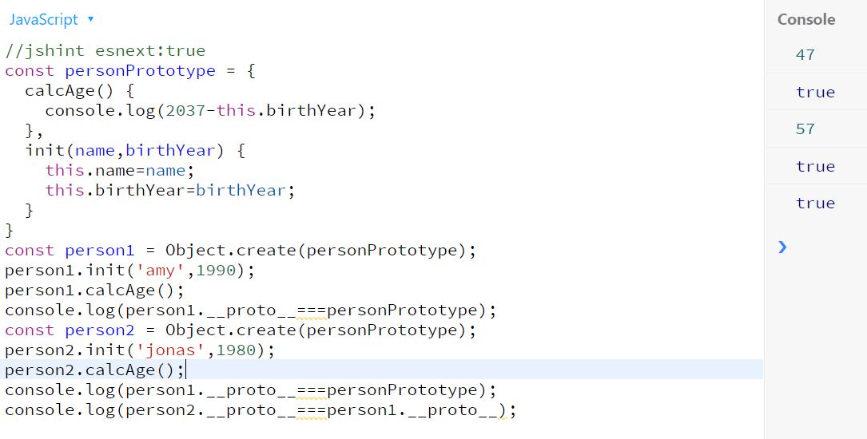

## 9. Inheritance between classes: constructor functions

1. we can also make one constructor function to extend from another constructor function. In this way we can use some fields and method of parent in child. Like Person class can have name and birthYear. And child class Student will inherit it from parent and has its own course field. Similarly calcAge method is prototype of parent and available to student and student has it own special method courseDetails.

2. to achieve inheritance hierarchy. We need to do below steps ->

2.1 need to call Parent constructor function inside child constructor to initialize fields present in parent. For that in first line if we call -> new Parent(name,year); then it will create new empty this and above to fields will not be set to the current this of Student object. So we need to call Parent constructor function and pass current this to be used. So we will use call method whose first argument will be this keyword to be used.

Example ->

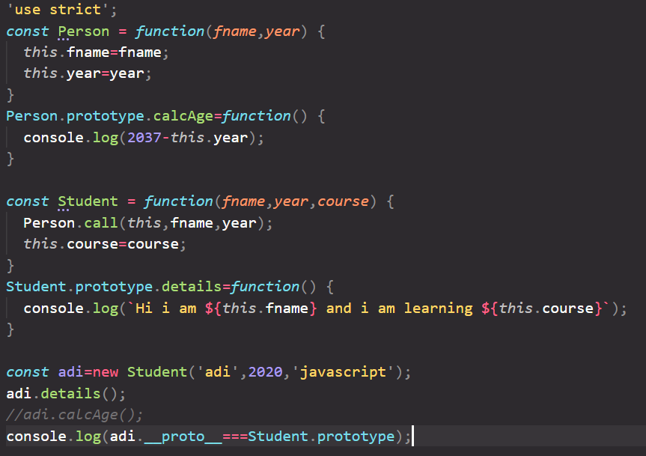

Here we have invoked Person function to initialize fname and year.

2.2 Now we want calcAge also to be available to all the Student objects. here adi __proto__ is Student.prototype and adi.__proto__.__proto__ is Object not Person. Or in other words we want Person.prototype to be the prototype of Student.prototype as Person.prototype has calcAge. We can use

Student.prototype=Object.create(Person.prototype);

Object.create will create new empty object with prototype Person set. After student.prototype is set then add details method to it (if we assign details first and then use create to assign prototype we will loose details method from older prototype as create return new empty object and overrides any existing prototype here from Student.)

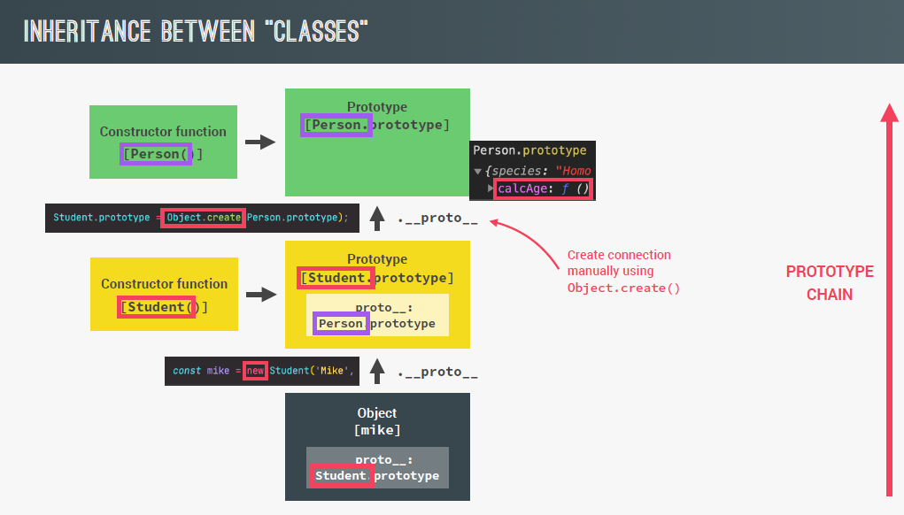

2.3 always use Object.create to assign prototype instead of Student.prototype=Person.prototype; as here in second case constructor function of Student and Person both will be same object.

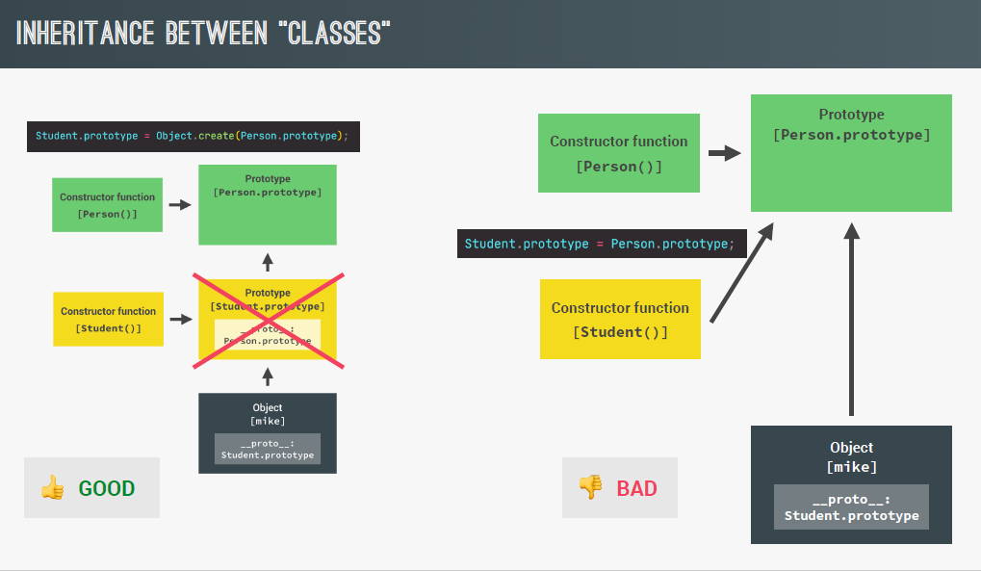

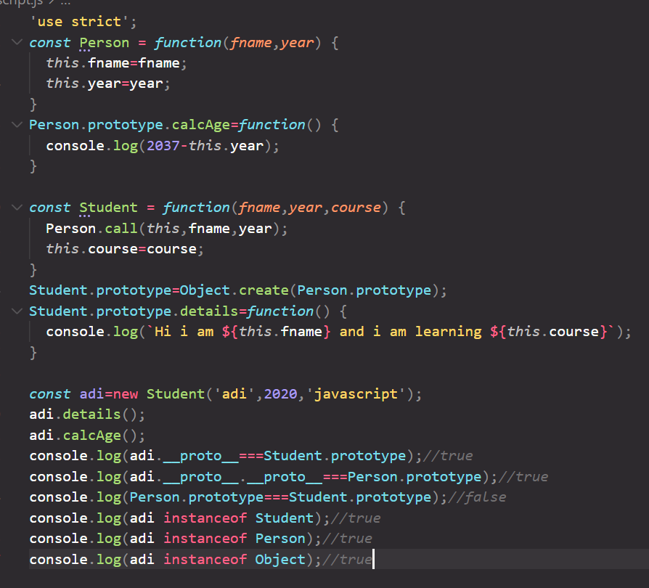

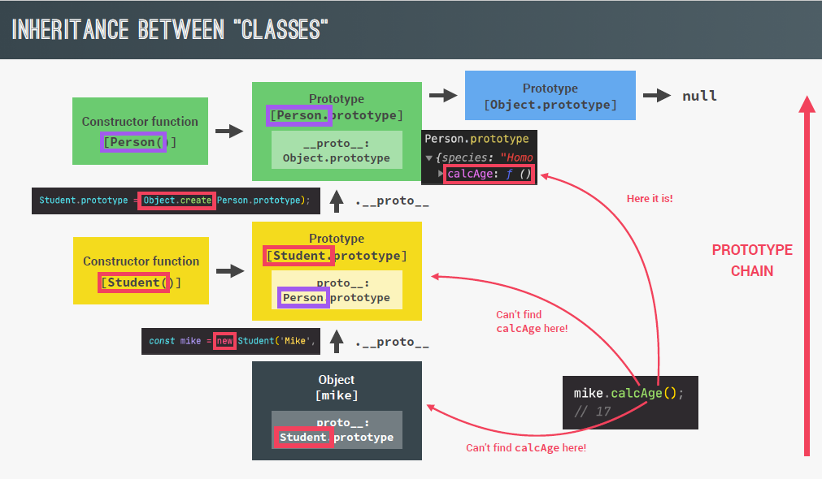

2.4 since we have manually assigned the prototype to create chain. Student.prototype.constructor will be Person here. But we want it to be Student. So assign Student.prototype.constructor=Student as a last step.

## 10. Inheritance between classes: ES6 classes

1. this approach is more like java approach of inheritance where child extends parent and call super to call parent constructor.

2. extends keyword link the prototype behind the scene. And super() will automatically call constructor function and passing current this automatically. super line should always happen as first line as it set this keyword also.

3. if child constructor does not have any new property then no need to write child constructor. js will create exact copy of parent constructor with same-args and call super for us in child.

Example. Input->

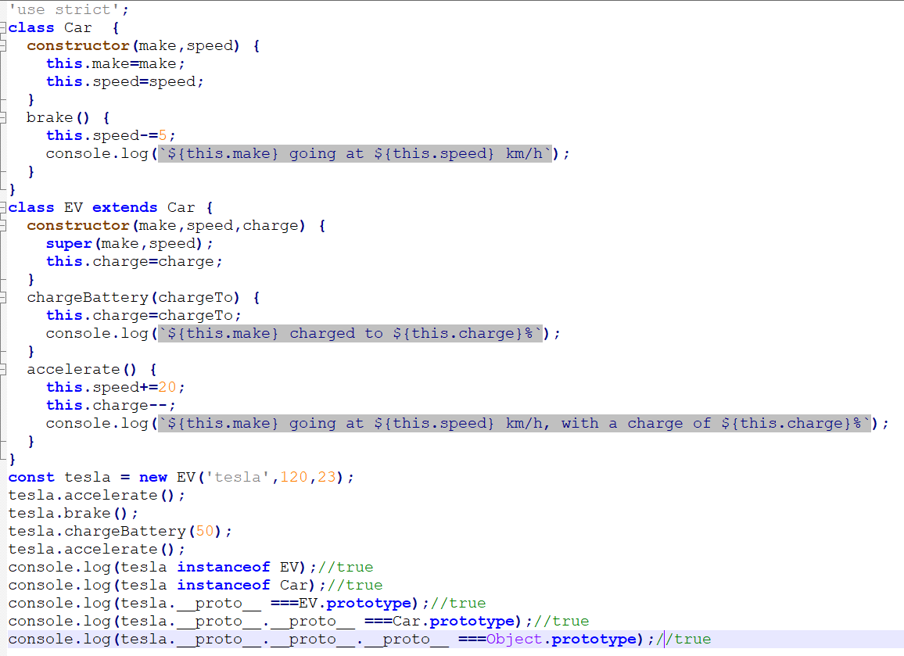

Output->

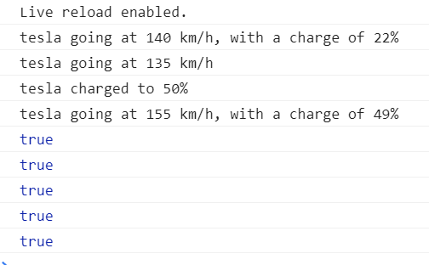

## 11. Inheritance between classes: traditional way via Object.create.

1. we know that Object.create take object to be set as prototype and return the empty object with prototype set.

2. so just create an object PersonPrototype and add methods to it calcAge and init. Inside init write this.fname and this.year to assign values to the object we want.

3. now Object.create(PersonPrototype) will return empty object with person prototype set. Use returned object to call init method and calcage method.

Like const steve= Object.create(PersonPrototype);

steve.init(‘steve’,2012);

4. now we want to introduce Student class in-between hierarchy and steve should now be object of Student. So, we can use empty returned object from Object.create(PersonPrototype); as a StudentPrototype. and can add updated init method and courseDetail method to this StudentPrototype object. Now we have hierarchy established.

*const* steve = Object.create(StudentProtoype);

steve.init('steve', 2012,'javascript');

5. this steve object has all the methods available from child as well as parent.

Complete Example->

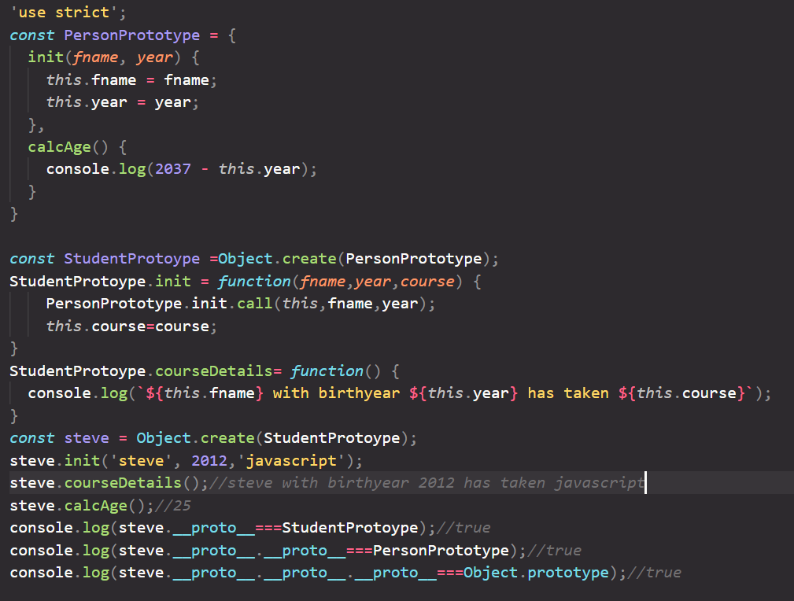

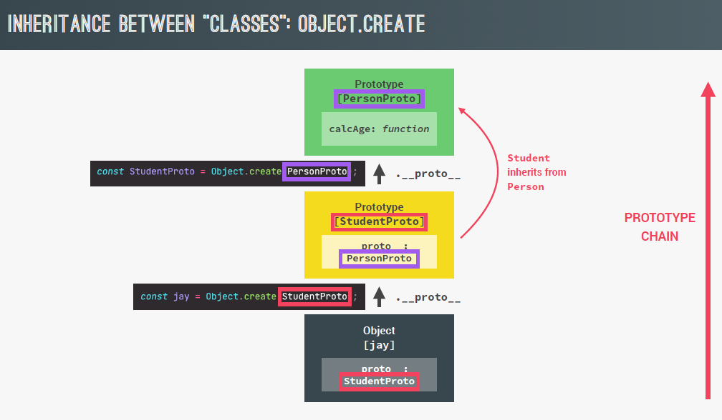

## 12. Encapsulation: protecting properties and methods

1. we don’t want everything of our class to be public. In JS there is no direct way to make method/fields private.

2. so it’s totally on developer now to not use some fields/methods outside the class. For that a convention of adding underscore in front of name of variable and method to give hint to programmer to not call it outside class is followed. Remember it is just a convention, java-script won’t give error if underscore fields used outside also.

Example ->

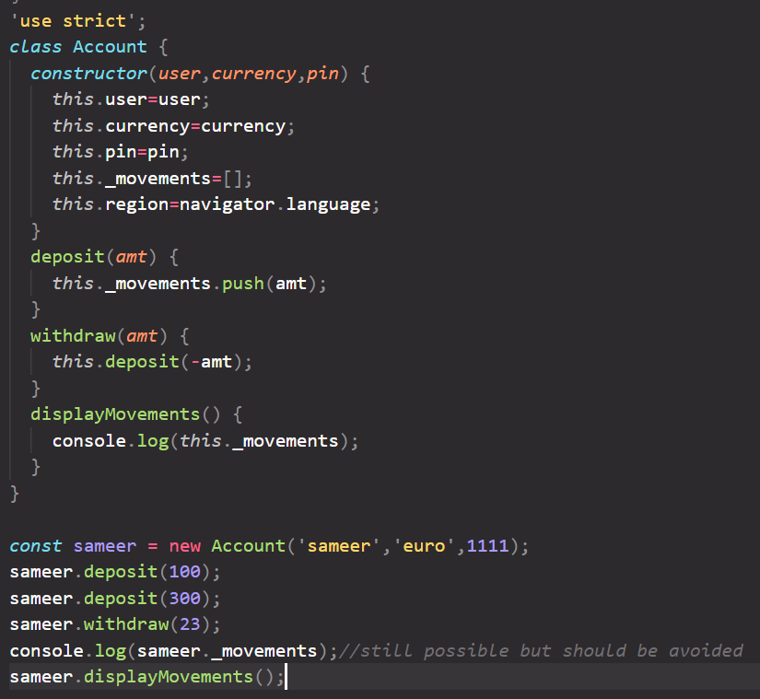

3. java script is also working on making truly private fields/methods in class. Which should not be available outside the class. It is currently under development. # will be prefixed to the variable/method name.

## 13. summary ES6 classes

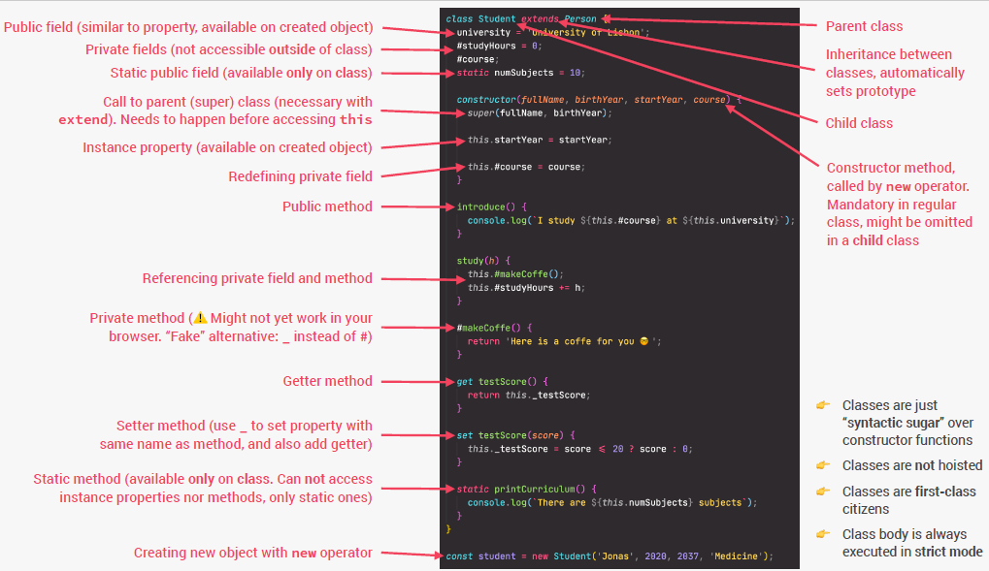

# Asynchronous JavaScript

## 1. Synchronous and Asynchronous Code

1. synchronous means code is executed line by line. Only after 1st line complete then 2nd line will be executed. So if first line takes time the code flow will be blocked. Like alert window. Until alert is closed then only next line will be executed.

2. async code will not stop main thread. And once the background task completed async code is executed. Example -> timeout function will call call-back method only after certain time elapsed. And in the mean-time rest of the code work. Async is non-blocking. Thread execution does not wait async task to get completed.

3. array map method takes call back method, but it is executed in synchronous manner. i.e. blocking.

4. img.src attribute loads the image in background and hence non-blocking and if we have registered load event then the required callback function will be invoked after images loads in UI.

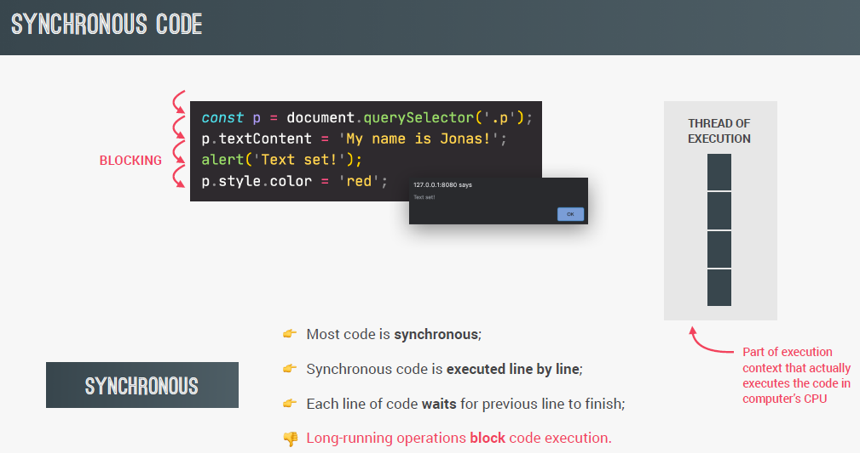

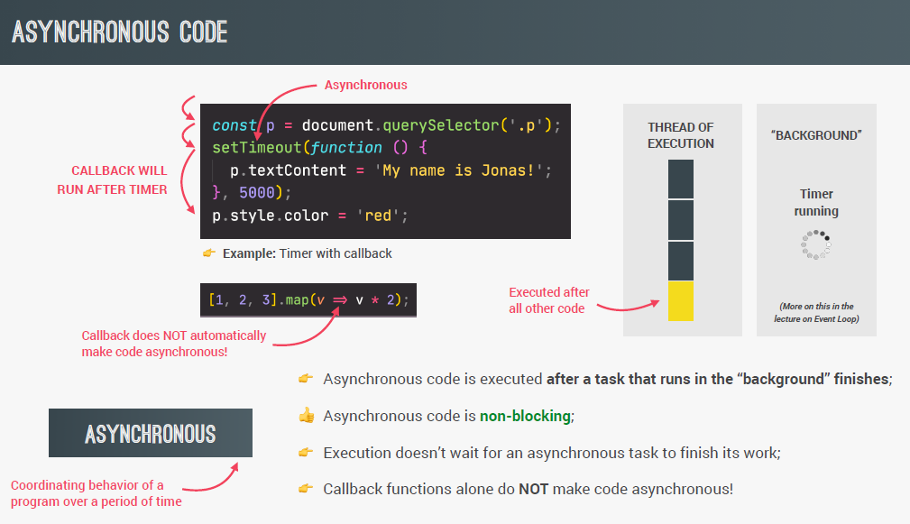

## 2. AJAX implementation via XMLHttpRequest

1. asynchronous java script and xml: allows us to communicate with remote web servers in asynchronous way. With ajax we can get data from server dynamically. Via AJAX only the part of the page is refreshed not the entire page loaded as in case of regular http request. For server ajax request is just like any normal request the only handling of response changes at client side. Callback function is called by javascript engine once the response received from server.

2. since json is used to transfer data now a days. Hence xml are rarely used as data in ajax. But name remains ajax.

3. there are different ways of making ajax call in JavaScript.

4. traditional approach requires creation of new XMLHttpRequest object. And then use this object to open a url and then send it. Then via load event of addEventListener we get the response in call-back function via this.responseText.

Example ->

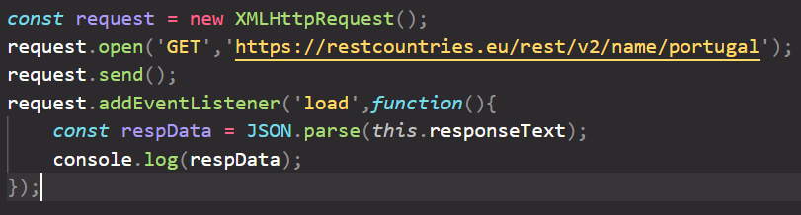

## 3. how request response works

**Case 1-> using get/post to get api response from server.**

1. first via the client browser rest end point is called. Via dns domain name is resolved to ip address of server and port on which the application is running.

2. now a tcp/ip connection is opened for the communication.

3. using tcp/ip connection httpRequest is send to server. (internally it goes in chunks to server and at server it assembled back to original request)

4. now server process the httpRequest and send httpResponse back to the client browser via tcp connection which is already opened.

5. after that tcp connection is closed.

**Case 2-> asking html page from server.**

1. in this case html page is received as a response of request via server.

2. now browser start rendering html and separate call is made for each resource needed in html like css file, images js file etc. and for each request server send the desired file.

3. once the entire page is rendered tcp/ip connection is closed.

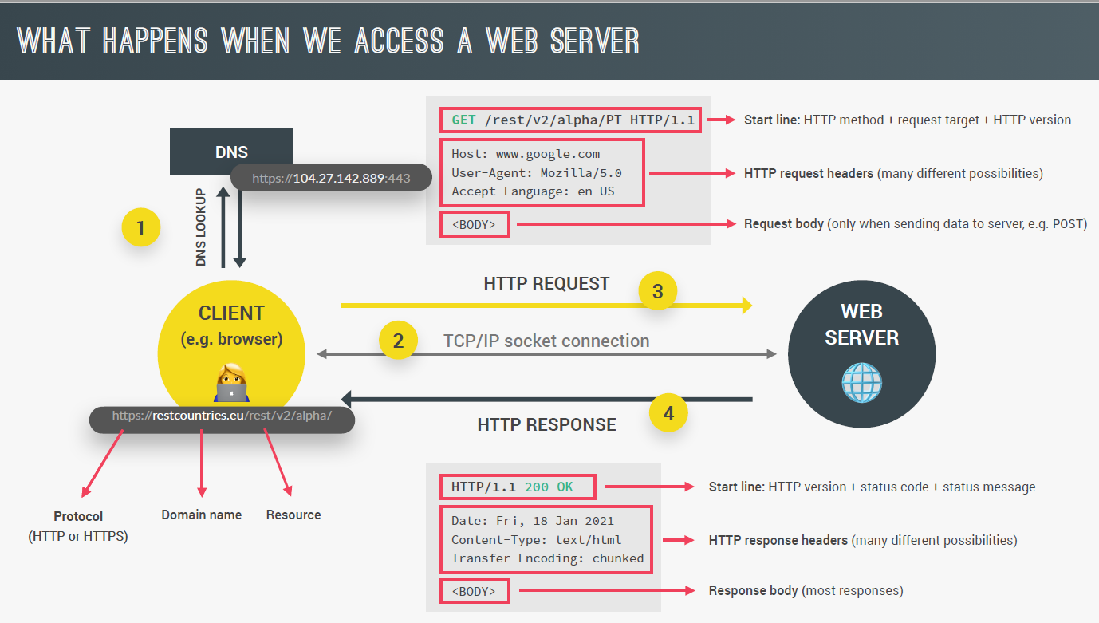

## 4. Maintain sequence in ajax calls (CallBack hell)

1. Suppose we want after the response of first ajax call is received then using some data of response call another ajax call.

2. directly if we just make normal 2 ajax calls order of response is dynamic and cannot be controlled.

3. In such case second ajax call can be made inside of call-back handler function of first ajax call. In this way they will be in desired sequence.

4. if we continue to add more callback inside callback of ajax it is called callback hell.

5. to avoid callback hell problem we can use promises.

## 5. AJAX implementation via Promises & fetch API

1. we can do same ajax call that is possible via XMLHttpRequest object with no boilerplate code via fetch method which will return Promise object as output.

2. Promise is an object that is used as a placeholder for the future result of an asynchronous operation. Example -> response of ajax call.

3. via promise we don’t need to rely on events and callbacks function to pass. And we can chain promises to make sequence one after other easily which help to avoid callback hell.

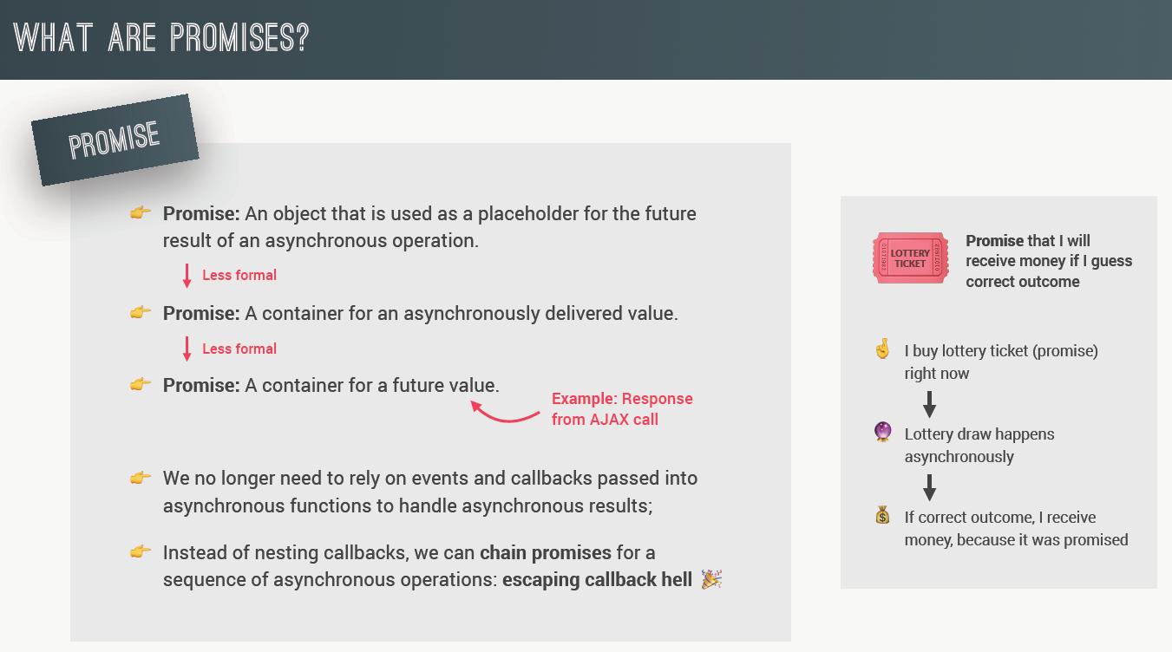

4. fetch api create a promise and return it directly. A promise initially will be on pending state. It indicates that async task is in progress. Once the task finished it can be either moved to fulfilled state(if response received successfully) or rejected state (for example resource not found).

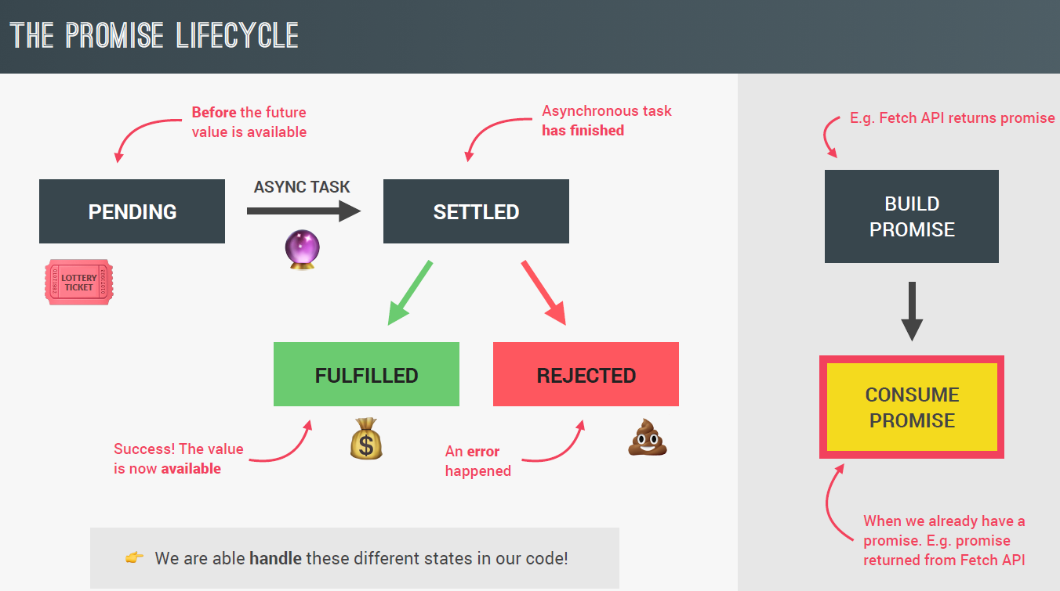

Example 1->

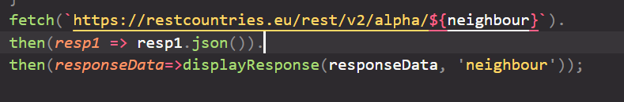

1. fetch method call the URL and return promise. Then method above call back is called only when promise is fulfilled successfully. then method always return promise as output and the value which we have returned inside callback will be passed as argument to the next then method if promise fulfilled. If we have not returned anything then in such case empty promise object will be returned.

2. here the value returned from then call-back method will be returned only if promise fulfilled.

3. inside call-back response.json() method will give the desired json object of response.

4. response.json method is itself async and return new promise object of the desired json response.

5. now again via chaining once promise is fulfilled call-back handler is called to handle and work with desired json object according to business use-case.

Example 2->

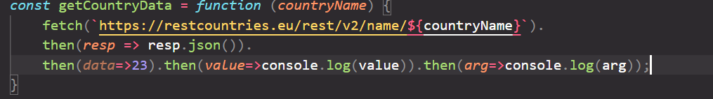

Here in first then we have explicitly returned promise object with json response as value of fulfilled promise.

Second then takes json response as argument and returned 23 as a fulfilled value of new promise.

Third then takes 23 as value and log it to console. Here we have not explicitly returned anything. So a new empty promise will be returned from this call.

Fourth then will be called with arg as undefined and hence log undefined. This method also returned new empty promise again.

## 6. Handle errors in Promises

1. those promises which are not fulfilled are called rejected promises and we need to handle it. Like while fetching data from url server goes down.

2. there are two ways to handle rejected promise. First is to pass second callback function inside then method. it will be called when promise is rejected. Error object is passed as argument to this method.

Example 1->

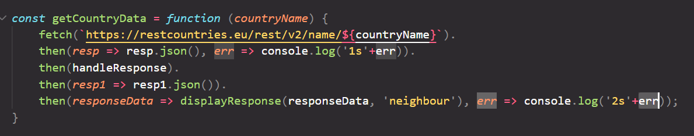

Here if error received while calling fetch api second arg callback will be invoked not the first one. And all the remaining fulfilled callbacks will not be invoked. If we have applied any additional error callback in the chain they will also get called. Like in this example last then method error callback handler will be executed also.

3. If we want to apply generic catch block instead of applying it in every then method. We can apply catch method to the last step of the chain. It will catch any error if occurred in any step.

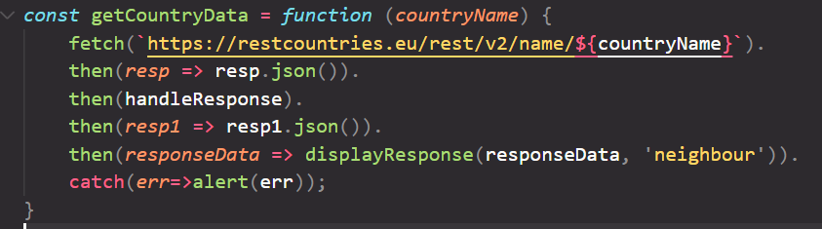

4. finally method should be applied to the last of promise chain. It will be executed always and we can do some generic work here if needed. It is not mandatory to apply it to last but should be preferred as after finally if any error occurred it will not be executed then. (As Finally also return promise which can be chained further)

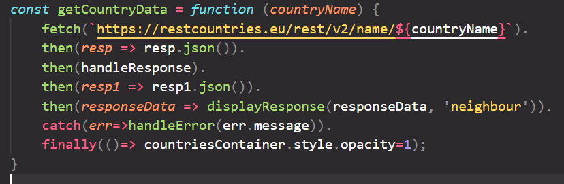

5. while calling api suppose countryName passed is invalid in such case resp object still be returned with status 404 and ok property as false. But since the response is received error handler will not be invoked, instead success handler will be called. To avoid this type of error in success handler code check if response.status===200 or response.ok===true. If not just throw exception manually.

